

**KULLIYYAH OF INFORMATION & COMMUNICATION TECHNOLOGY**

**CSCI 3303 MATHEMATICS FOR COMPUTING III**

**SEMESTER 2, 2024/2025**

**SECTION 01**

**TITLE: Stochastic Forecasting of Greenhouse Gas Emissions: A Ten‑Country Markov Chain Approach**

**PREPARED BY Group C:**

|  |  |
| --- | --- |
| **NAME** | **MATRIC NO.** |
| MUHAMMAD UMAIR ASYRAAF BIN SAMSURI | 2317901 |
| YUSUF MOHAMMAD YUNUS | 2314467 |
| ALNATSHEH HUTHIFA M J | 2229009 |
| MUHAMMAD AIMAN BIN ABDUL RAZA | 2312215 |

**LECTURER**

DR. AKEEM OLOWOLAYEMO

**DUE**

9th June 2025

**Table of Contents**

**1.0 OVERVIEW 4**

1.1 INTRODUCTION 4

1.2 MARKOV CHAIN 5

1.3 PROBLEM STATEMENT 5

1.4 OBJECTIVE 5

**2.0 RELATED WORK 6**

2.1 Estimating the Emissions Reductions Needed to Meet the 2°C Warming Target (Liu & Raftery, 2021) 6

2.2 Hidden Markov Models for Presence Detection Based on CO2 Fluctuations (Karasoulas et al., 2023) 6

2.3 An Algorithm for Predicting Carbon Emission Trends Based on Adaptive Hidden Markov Models (Wan et al., 2024) 6

2.4 Optimizing Climate-Related Global Development Pathways in the Global Calculator Using Monte Carlo Markov Chains and Genetic Algorithms (Garcia et al., 2022) 6

2.5 How do green energy investment, economic policy uncertainty, and natural resources affect greenhouse gas emissions? A Markov-switching equilibrium approach (Hassan et al., 2022) 7

2.6 Greenhouse Gas Emissions from Heavy-Duty Vehicles in Ireland (Middela et al., 2024) 7

2.7 Compound extremes in a changing climate – a Markov chain approach (Sedlmeier et al., 2016) 7

2.8 Applications of Markov Chain in Forecast (Xia Yutong, 2021) 7

2.9 Analysis of Air Quality Parameters on Climate Change Phenomenon Using Markov Autoregressive Model (VijayaShanthy et al., 2024) 7

2.10 Modeling the Spatio-Temporal Dynamics of Air Pollution Index Based on Spatial Markov Chain Model (Alyousifi et al., 2020) 7

2.11 Research on the Methodology of Carbon Emission Prediction Under Dual Carbon Target Based on Improved Gray Markov Model (Zhu et al., 2025) 8

2.12 Locating and Quantifying Methane Emissions by Inverse Analysis of Path-Integrated Concentration Data Using a Markov-Chain Monte Carlo Approach (Weidmann et al., 2022) 8

**3.0 METHODOLOGY 8**

3.1 General introduction/overview of the linear algebra method. 8

3.2 General types of problems Markov Chain rule is used to solve. 8

3.3 Write the general formulation of the equations from the textbook. 9

**4.0 VARIABLE & DATA SOURCES 9**

Total greenhouse CO2 gas emissions (kt of CO2 equivalent) (Excluding LULUCF) 9

Total Greenhouse (excl. LULUCF & CO2) gas emissions. (Thousand metric tons of CO2 equivalent) 15

**5.0 RESULTS 19**

5.1.1 Australia Gas Emissions (CO2) 19

5.1.2 Australia Gas Emissions (HFC, PFC, and SF6) 20

5.2.1 Ukraine Gas Emissions (CO2) 22

5.2.2 Ukraine Gas Emissions (HFC, PFC, and SF6) 23

5.3.1 Malaysia Gas Emissions (CO2) 25

5.3.2 Malaysia Gas Emissions (HFC, PFC, and SF6) 26

5.4.1 United Kingdom Gas Emission (Co2) 28

5.4.2 United Kingdom Gas Emissions (HFC, PFC, and SF6) 29

5.5.1 Russia Gas Emissions (CO2) 31

5.5.2 Russia Gas Emissions (HFC, PFC, and SF6) 32

5.6.1 India Gas Emissions (CO2) 34

5.6.2 India Gas Emissions (HFC, PFC, and SF6) 35

5.7.1 France Gas Emissions (CO2) 37

5.7.2 France Gas Emissions (HFC, PFC, and SF6) 38

5.8.1 Japan Gas Emissions (CO2) 40

5.8.2 Japan Gas Emissions (HFC, PFC, and SF6) 41

5.9.1 Germany Gas Emissions (CO2) 43

5.9.2 Germany Gas Emissions (HFC, PFC, and SF6) 44

5.10.1 Canada Gas Emissions (CO2) 46

5.10.2 Canada Gas Emissions (HFC, PFC, and SF6) 47

6.0 RESULT ANALYSIS 49

6.1 Which Country Is Contributing More to Climate Changing 49

6.2 Best Factor for Climate Change 69

CO₂ Emissions: 69

Other Gases (HFCs, PFCs, SF₆): 69

Overall Comparison: 69

Conclusion: 69

6.3 Prediction for Climate Change 70

**7.0 Recommendations for High Emission Countries 76**

**8.0 CONCLUSION 7**8

**9.0 Appendix 7**9

**10.0 REFERENCES 80**

# 

# 1.0 OVERVIEW

## 1.1 INTRODUCTION

Our project topic is about analyzing the change of the climate and the most prominent factors of it . Climate change has become one of the most urgent and complex challenges faced by humanity today. From rising sea levels to extreme weather events, the evidence of a warming planet is becoming more visible and more difficult to ignore. At the core of this global crisis is the excessive release of greenhouse gases into the atmosphere, particularly **carbon dioxide (CO₂)**, which is largely emitted through human activities such as burning fossil fuels, deforestation, and industrial operations.

While the Earth has naturally experienced cycles of warming and cooling throughout its long history, such as during the Ice Ages, the current rate of climate change is unprecedented. For instance, after the last Ice Age around 20,000 years ago, global temperatures increased gradually over thousands of years. In comparison, the industrial revolution, which began just over 150 years ago, has caused a rapid and dramatic spike in atmospheric CO₂ levels. Since the 1850s, concentrations of CO₂ have risen by more than 48%, a change driven almost entirely by human behaviour.

In addition to carbon dioxide, other synthetic greenhouse gases have also contributed significantly to global warming. These include **hydrofluorocarbons (HFCs)**, which are commonly used as refrigerants; **perfluorocarbons (PFCs)**, often emitted during aluminium production and semiconductor manufacturing; **sulphur hexafluoride (SF₆)**, an extremely potent gas used in the electrical industry as an insulator; and **nitrogen triflouride (NF₃)**, used in semiconductor and solar panel production. Although these gases are released in smaller quantities than CO₂, their heat-trapping abilities are much greater, making them important factors in climate studies.

In this project, we aim to analyze the emissions of CO₂ & other greenhouse gases like HFCs, PFCs, and SF₆ across ten selected countries: Australia, Ukraine, Malaysia, the United Kingdom, Russia, India, France, Japan, Germany, and Canada. Using historical data and mathematical modelling, particularly the *Markov Chain method*, we will explore which of these factors plays the most prominent role in accelerating climate change. Our analysis will also compare how these gases have evolved over time in each country, helping us understand the global and regional contributions to this critical issue. Through this research, we hope to highlight the most impactful factors in climate change and support efforts to reduce emissions effectively.

## 1.2 MARKOV CHAIN

A Markov chain is a stochastic model that considers several alternative outcomes, with the probability of each occurrence being determined solely by the condition met in the first instance. It's a cycle that occurs in a series of time-steps, each of which involves an erroneous decision between a finite (or enumerable) set of states.; since both the index set and the state space are discrete, XnX(TN) is denoted; the probability of transition can then be expressed by a matrix P=(pij), where pij is the probability of going from the state I to state j: pij=Prob[Xn+1=j|Xn=i].

The Markov chain method is used to predict the expected outcome of the factors that lead to climate change. How much is it changing, and which one is the most common factor? Based on the given and calculated results from the statistics on all factors, we can use the Markov chain method to predict the percentage value of all factors, which we then compare to get the best factor that contributes to our objective.

## 1.3 PROBLEM STATEMENT

The world’s climate is changing rapidly. There are many factors that contribute to climate change. In our project, we will conduct an analysis based on 10 different countries: Australia, Ukraine, Malaysia, the United Kingdom, Russia, India, France, Japan, Germany, and Canada. We will do mean, median and hypothesis. The two most important influencers of climate change are emissions of carbon dioxide and other greenhouse gases (GHG) which are methane (CH4), nitrous oxide (N2O), hydrofluorocarbons (HFCs), perfluorocarbons (PFCs), and sulphurhexafluoride (SF6) from the energy, industry, waste, and agriculture sectors, standardized to carbon dioxide equivalent values. This measure excludes GHG fluxes caused by Land Use Change, Land Use and Forestry (LULUCF), as these fluxes have larger uncertainties. The measure is standardised to carbon dioxide equivalent values using the Global Warming Potential (GWP) factors of IPCC's 5th Assessment Report (AR5). In this report, we will compare which are the major factors of climate change.

## 1.4 OBJECTIVE

The objective of this research is as below:

* To determine whether the rate of climate change is increasing or decreasing.
* To find out the best factor which is causing more harm to our environment.
* We will calculate the CO2 rate in different countries and decide which country is causing the most global warming effects.
* We will take data globally, and we will compare it with countries. Since climate change is a big problem throughout the whole world. We aim to prove that.

# 2.0 RELATED WORK

## 2.1 Estimating the Emissions Reductions Needed to Meet the 2°C Warming Target (Liu & Raftery, 2021)

The article is about figuring out how much we need to cut emissions to keep global warming below 2°C. It found that big polluters like the USA (2% chance) and China (16% chance) probably won't meet their climate goals. Right now, there's only a 5% chance of staying under 2°C. While the article doesn't go into detail about the math, this type of analysis, dealing with probabilities and future predictions, often uses linear algebra and statistical methods. For example, it might involve Markov chains to model how our emissions "transition" from one state to another, or regression analysis to predict future emission trends based on current data. These tools are commonly used in many fields to understand systems that change over time, from economics to biology.

## 2.2 Hidden Markov Models for Presence Detection Based on CO2 Fluctuations (Karasoulas et al., 2023)

This article investigates using Hidden Markov Models (HMMs), a linear algebra-based approach, and CO2 concentration fluctuations to detect human presence indoors. It addresses the limitations of traditional motion and camera sensors by proposing CO2 sensors as a low-cost, non-intrusive alternative. The authors developed a simple Markov Chain Model, which relies on transition probability matrices and emission probability matrices, core linear algebra concepts to infer hidden states (presence or absence) from observed CO2 levels. This method achieved high accuracy (up to 97%) in detecting occupancy in both experimental and real-world data, demonstrating the practical efficacy of using probabilistic models derived from linear algebra for real-time applications like HVAC and lighting control.

## 2.3 An Algorithm for Predicting Carbon Emission Trends Based on Adaptive Hidden Markov Models (Wan et al., 2024)

This article proposes an algorithm for predicting carbon emission trends using an adaptive Hidden Markov Model (HMM), a powerful linear algebra-based statistical framework. Recognizing the complex interplay of factors influencing emissions, the authors construct an index system of influencing factors, such as energy structure and industrial population size, to serve as the hidden state parameters of the HMM. The algorithm leverages core linear algebra concepts, including transition probability matrices (describing the likelihood of moving between hidden states) and observation probability distributions (relating hidden states to observed carbon emission levels). By incorporating time complexity and adaptive attributes, the model learns from historical data to dynamically update these probabilities and generate future carbon emission prediction sequences, demonstrating high accuracy with prediction errors consistently within 2.0×10^4 tons, thus showcasing the HMM's robust capability for complex time-series forecasting.

## 2.4 Optimizing Climate-Related Global Development Pathways in the Global Calculator Using Monte Carlo Markov Chains and Genetic Algorithms (Garcia et al., 2022)

This article explains how a tool called the 'Global Calculator', which predicts future energy, food, and land use, is being optimized to reach global climate goals. Because this tool has a huge number of possible settings, researchers used advanced computing methods based on linear algebra: Monte Carlo Markov Chains (MCMC) and genetic algorithms. MCMC helps explore many different options efficiently by moving through possibilities based on probabilities, like how a random walk works. Genetic algorithms, inspired by natural selection, 'evolve' better solutions over time by combining and selecting the best settings, much like how species adapt and improve. These methods, which rely on mathematical operations to navigate complex search spaces, allowed them to find the best settings in the Global Calculator to both reduce CO2 emissions significantly and boost economic growth (GDP), proving they can create effective and customized plans for a sustainable future.

## 2.5 How do green energy investment, economic policy uncertainty, and natural resources affect greenhouse gas emissions? A Markov-switching equilibrium approach (Hassan et al., 2022)

This study investigates how green energy investment, economic policy uncertainty, and natural resources impact greenhouse gas (GHG) emissions in China. To do this, they used a sophisticated method called a Markov-switching equilibrium correction model. This model, a type of Hidden Markov Model (HMM) based on linear algebra, is like having different 'modes' or 'states' for the economy, such as times of high or low policy uncertainty, and it allows the relationships between these factors and emissions to change depending on which mode the economy is in. These 'switches' between modes happen based on probabilities, which are represented by transition matrices. This approach allowed them to discover that green energy investment helps the environment, while natural resources and economic uncertainty hurt it, ultimately pushing for more green energy investment.

## 2.6 Greenhouse Gas Emissions from Heavy-Duty Vehicles in Ireland (Middela et al., 2024)

This study looked at CO2 emissions from large trucks in Ireland, a key area for cutting overall pollution. Researchers used a special tool called VECTO, but they made it more accurate by creating new driving patterns based on real Irish roads. They found that using these Irish-specific patterns changed the estimated CO2 emissions, showing the importance of local conditions. The study also highlighted how factors like the truck's weight, road hills, and idling time affect fuel use and emissions, noting that ignoring hills can lead to underestimating fuel consumption by over 7%. This research provides important information for Irish policymakers to help reduce truck pollution.

## 2.7 Compound extremes in a changing climate – a Markov chain approach (Sedlmeier et al., 2016)

This article applied a Markov chain model to forecast the probability of heatwaves in Iran. The model was trained using a dataset of daily maximum temperatures from 1980 to 2010. The study found that the model could predict heatwaves with high accuracy. According to the researchers, the Markov chain model is a promising method for predicting heatwaves and could be used to develop early warning systems for such events.

## 2.8 Applications of Markov Chain in Forecast (Xia Yutong, 2021)

This article introduces the concept of the Markov chain and its practical applications, particularly in business forecasting. The author explains the theory using two daily life examples to illustrate that in a Markov process, the probability of a future state depends solely on the immediately preceding state. By constructing transition probability matrices, the study demonstrates how mathematical models for market and weather forecasting can be built, analyzed, and computed using Markov chains. Through data analysis and calculation verification, the article concludes that the Markov chain is a scientific, effective, and convenient method for prediction, applicable to solving various daily issues.

## 2.9 Analysis of Air Quality Parameters on Climate Change Phenomenon Using Markov Autoregressive Model (VijayaShanthy et al., 2024)

This research developed a portable device to monitor air pollution and harmful gas emissions, like NOx, in real-time. It uses an Internet of Things (IoT) system to send data every 2 seconds to smart devices, comparing it against standard air quality levels. The goal is to use this data with a Markov autoregressive model to predict climate conditions and give early warnings for pollution, helping us take action to protect the environment.

## 2.10 Modeling the Spatio-Temporal Dynamics of Air Pollution Index Based on Spatial Markov Chain Model (Alyousifi et al., 2020)

This study used a spatial Markov chain model to analyze how air pollution levels in one location affect, and are affected by, neighboring areas in Peninsular Malaysia. The research found that a station's air quality is significantly dependent on its neighbors' pollution states, with cleaner neighbors increasing the probability of a station remaining clean.

## 2.11 Research on the Methodology of Carbon Emission Prediction Under Dual Carbon Target Based on Improved Gray Markov Model (Zhu et al., 2025)

This paper proposes a carbon emission prediction method that utilizes an improved gray Markov model. The approach involves calculating carbon emissions at various times using the carbon emission factor method, then creating a cumulative sequence. The state transition for the Markov process is determined by analyzing the relative error of gray prediction results. Finally, carbon emission prediction values are calculated, with their arithmetic average taken as the final prediction result. Experimental findings indicate that the predicted outputs from this method are closer to the actual values, demonstrating its effectiveness for carbon emission forecasting under dual carbon targets.

## 2.12 Locating and Quantifying Methane Emissions by Inverse Analysis of Path-Integrated Concentration Data Using a Markov-Chain Monte Carlo Approach (Weidmann et al., 2022)

This article presents a novel area monitoring approach to locate and quantify methane emissions, a significant challenge in reducing greenhouse gas pollution. The method utilizes laser dispersion spectroscopy to measure path-averaged methane concentrations across multiple beams. By integrating this data with a Gaussian plume gas dispersion model and employing a Markov-chain Monte Carlo (MCMC) analysis, the system identifies source locations and emission rates. The approach was tested with 19 calibrated methane releases in a 175m x 175m area, demonstrating high accuracy: it correctly located sources within 9 meters in over 75% of cases and achieved better than 30% accuracy for mass emission rates in 70% of cases, with discrepancies typically less than 2 kg/h. This method provides a promising tool for precisely identifying and measuring methane leaks.

# 3.0 METHODOLOGY

## 3.1 General introduction/overview of the linear algebra method.

**A Markov chain is a mathematical framework used to model sequences of events in which the likelihood of moving to a future state depends only on the present state, not on the sequence of events that happened before it. This type of process is called** *stochastic*, meaning it involves *randomness*.

Markov chains are defined by a set of possible states and the probabilities of transitioning between them. These probabilities are organized into a square matrix known as the *transition matrix* or *stochastic matrix,* where each row represents a current state and each column shows the probability of moving to a next state. By multiplying this matrix by itself repeatedly (raising it to a power), one can determine the probability of transitioning between states over several steps. This allows for analysis of the system’s behavior over time, including identifying the *steady-state distribution*, which represents the long-term probability of being in each state. Markov chains are widely used to study and predict the behavior of systems governed by probabilistic rules.

## 3.2 General types of problems Markov Chain rule is used to solve.

Markov chains are applied in a wide range of fields to solve various types of problems. They are especially valuable in probabilistic modeling, where they help represent the behavior of systems influenced by randomness, such as fluctuations in stock markets, climate variations, population growth, and the transmission of diseases. Additionally, Markov chains are effective in modeling random walks, studying queueing systems, addressing optimization challenges through Markov decision processes (MDPs), and supporting natural language processing tasks like text generation and prediction. These diverse applications demonstrate the flexibility and usefulness of Markov chains in analyzing, forecasting, and improving systems that exhibit probabilistic characteristics.

## 3.3 Write the general formulation of the equations from the textbook.

We examine a discrete-time, discrete-space stochastic process denoted as

*X(t) = Xt , for t = 0,1,....*

The state space *S* is discrete—either finite or countably infinite—so we can represent it as a set of integers, such as:

*S = {1,2,...,N} or S = {1,2,...}*

The sequence *X(t) = X0,X1,X2,...* is considered a discrete-time Markov chain if it satisfies the Markov property:

*P(Xn+1 = s | X0 = x0, X1 = x1, … , Xn = xn) = P(Xn+1 = s | Xn = xn)*

This property means that the future state depends only on the present state and not on the sequence of past states.

The values *P( Xn + 1 = j | Xn = i )* are referred to as **transition probabilities** and are generally dependent on the current state iii, the next state jjj, and the time step nnn. For convenience, these probabilities are denoted as:

*pij (n) = P( Xn + 1 = j | Xn = i )*

The collection of these probabilities at time nnn forms the **transition matrix** P(n) = (pij (n) ), where the entry in the i-th row and j-th column corresponds to pij (n).

This matrix satisfies two key conditions:  
 (i) *pij(n) ≥ 0 ∀ i, j* (the entries are non-negative)   
 (ii) *∑j pij(n) = 1 ∀ i* (the rows sum to 1)

Any matrix that meets these two conditions is known as a **stochastic matrix**, so the transition matrix P(n) is stochastic.

A Markov chain X(t) is said to be **time-homogeneous** if the transition probabilities are independent of time *n*; that is,

***P(Xn + 1 = j | Xn = i) = P(X1 = j | X0 = i)***

In this case, we write

***pij = P( X1 = j | X0 = i )***

*to denote the one-step transition probability from state i to state j, and define the transition matrix as P=(pij).*

*In this , we will focus solely on time-homogeneous Markov chains, though we may occasionally comment on how certain results extend to the time-inhomogeneous case.*

# 

# 4.0 VARIABLE & DATA SOURCES

## Total greenhouse CO2 gas emissions (kt of CO2 equivalent) (Excluding LULUCF)

|  |  |  |  |  |  |  |  |  |  |  |
| --- | --- | --- | --- | --- | --- | --- | --- | --- | --- | --- |
| **Country Name** | **1970** | **1971** | **1972** | **1973** | **1974** | **1975** | **1976** | **1977** | **1978** | **1979** |
| **Australia** | 160.3769 | 162.1077 | 167.9569 | 177.3185 | 186.8463 | 193.595 | 196.384 | 209.6638 | 205.9886 | 211.8454 |
| **Ukraine** | 477.2242 | 476.8572 | 502.4115 | 532.108 | 556.1456 | 582.1754 | 600.1396 | 610.5376 | 653.2175 | 667.0468 |
| **Malaysia** | 26.8826 | 27.2778 | 14.3218 | 14.8103 | 17.8525 | 19.2436 | 21.2425 | 21.1059 | 27.1876 | 31.2059 |
| **United Kingdom** | 673.4202 | 668.6714 | 657.7172 | 690.031 | 644.6402 | 623.6572 | 629.8113 | 638.3125 | 636.4771 | 672.6636 |
| **Russia** | 1307.9918 | 1308.9747 | 1377.0903 | 1460.8889 | 1536.3042 | 1620.8224 | 1681.8341 | 1719.5681 | 1841.6854 | 1867.6469 |
| **India** | 213.9344 | 214.4281 | 222.9632 | 221.9373 | 237.6409 | 253.2017 | 270.6936 | 276.0218 | 271.347 | 291.7332 |
| **France** | 469.4414 | 481.5545 | 499.1043 | 535.7473 | 517.0076 | 476.4954 | 521.9985 | 503.433 | 521.4465 | 529.0211 |
| **Japan** | 848.7516 | 846.4521 | 893.0016 | 1006.6245 | 1003.1882 | 948.6801 | 980.7332 | 1005.7789 | 1006.3741 | 1030.144 |
| **Germany** | 1084.6575 | 1077.4192 | 1105.2903 | 1157.7203 | 1122.5066 | 1060.5661 | 1122.9347 | 1101.4441 | 1139.317 | 1189.4771 |
| **Canada** | 358.1272 | 365.7851 | 383.0355 | 401.9821 | 410.0579 | 400.2143 | 413.3629 | 427.8718 | 431.0299 | 445.1962 |

|  |  |  |  |  |  |  |  |  |  |  |
| --- | --- | --- | --- | --- | --- | --- | --- | --- | --- | --- |
| **Country Name** | **1980** | **1981** | **1982** | **1983** | **1984** | **1985** | **1986** | **1987** | **1988** | **1989** |
| **Australia** | 222.0147 | 222.9747 | 229.2624 | 217.7334 | 223.519 | 237.9354 | 238.3953 | 249.5845 | 258.3833 | 274.1612 |
| **Ukraine** | 684.8723 | 674.3338 | 672.4168 | 672.9621 | 676.0755 | 678.3837 | 692.5807 | 713.9627 | 722.0811 | 718.2876 |
| **Malaysia** | 32.3916 | 33.0891 | 35.7918 | 41.0466 | 43.1615 | 42.7145 | 43.9599 | 44.7952 | 47.9098 | 56.6283 |
| **United Kingdom** | 608.3254 | 589.021 | 573.101 | 566.2653 | 549.9603 | 576.5427 | 590.5337 | 595.1847 | 592.8904 | 579.2874 |
| **Russia** | 1929.3114 | 1923.5418 | 1951.446 | 1985.1133 | 2020.4148 | 2059.49 | 2126.7823 | 2189.1639 | 2241.0717 | 2252.9505 |
| **India** | 303.5765 | 333.9885 | 351.9038 | 374.5973 | 412.8617 | 431.4118 | 468.5979 | 501.4341 | 532.2986 | 570.1243 |
| **France** | 507.05 | 456.7116 | 435.6642 | 416.5339 | 404.9673 | 394.7068 | 382.601 | 375.7727 | 375.8439 | 390.36 |
| **Japan** | 1003.1434 | 981.5855 | 939.7607 | 943.2447 | 1011.0488 | 983.4576 | 980.48 | 987.784 | 1060.6681 | 1090.4943 |
| **Germany** | 1135.5984 | 1099.9653 | 1054.0401 | 1069.5505 | 1085.7373 | 1086.3402 | 1080.194 | 1072.2524 | 1065.9799 | 1050.769 |
| **Canada** | 450.4307 | 431.7735 | 413.774 | 407.4239 | 426.7784 | 426.65 | 416.5804 | 429.3182 | 460.3398 | 475.4707 |

|  |  |  |  |  |  |  |  |  |  |  |
| --- | --- | --- | --- | --- | --- | --- | --- | --- | --- | --- |
| **Country Name** | **1990** | **1991** | **1992** | **1993** | **1994** | **1995** | **1996** | **1997** | **1998** | **1999** |
| **Australia** | 277.7123 | 279.7336 | 283.1129 | 287.0239 | 292.3756 | 302.6923 | 312.6713 | 322.3709 | 342.1087 | 348.1127 |
| **Ukraine** | 785.5447 | 741.0614 | 648.3748 | 565.9997 | 468.4401 | 462.6363 | 396.2374 | 380.9966 | 363.5368 | 363.2923 |
| **Malaysia** | 64.4223 | 75.3034 | 79.2844 | 79.4983 | 87.5645 | 90.9385 | 103.4302 | 113.2578 | 110.6673 | 119.6946 |
| **United Kingdom** | 582.349 | 591.4813 | 578.1824 | 562.1317 | 554.6245 | 548.0823 | 567.3642 | 546.492 | 547.1041 | 543.7186 |
| **Russia** | 2436.2592 | 2393.5273 | 2200.8303 | 2008.7494 | 1811.1206 | 1765.1898 | 1724.2331 | 1604.8446 | 1611.1046 | 1660.9052 |
| **India** | 600.6873 | 646.3888 | 669.6642 | 699.7562 | 743.8583 | 796.4639 | 833.512 | 877.7065 | 900.6255 | 961.6311 |
| **France** | 385.272 | 410.3361 | 396.929 | 377.283 | 373.0042 | 382.0537 | 396.7419 | 388.4739 | 410.4713 | 404.1642 |
| **Japan** | 1166.8237 | 1176.8604 | 1181.8812 | 1174.7455 | 1227.961 | 1238.6398 | 1251.4624 | 1236.9539 | 1189.7637 | 1230.7275 |
| **Germany** | 1013.0316 | 992.0353 | 938.1013 | 929.647 | 915.6041 | 910.8205 | 939.6957 | 907.821 | 906.9508 | 871.0236 |
| **Canada** | 440.4753 | 434.5216 | 447.282 | 446.6273 | 463.8531 | 475.9147 | 489.835 | 505.6071 | 513.8019 | 523.3953 |

|  |  |  |  |  |  |  |  |  |  |  |
| --- | --- | --- | --- | --- | --- | --- | --- | --- | --- | --- |
| **Country Name** | **2000** | **2001** | **2002** | **2003** | **2004** | **2005** | **2006** | **2007** | **2008** | **2009** |
| **Australia** | 353.8697 | 360.4081 | 368.6209 | 368.115 | 381.942 | 384.0857 | 390.1513 | 400.6653 | 404.2851 | 410.2594 |
| **Ukraine** | 360.0221 | 359.0635 | 359.6469 | 392.02 | 367.8053 | 356.0703 | 355.3087 | 366.3142 | 350.633 | 290.6597 |
| **Malaysia** | 130.7796 | 138.4076 | 146.5554 | 156.576 | 169.6248 | 181.1517 | 187.7708 | 204.9404 | 216.1782 | 197.9811 |
| **United Kingdom** | 551.6797 | 562.9085 | 546.9059 | 560.427 | 560.9379 | 559.3283 | 559.7568 | 550.2287 | 533.7479 | 483.3614 |
| **Russia** | 1681.1439 | 1684.2625 | 1675.2806 | 1737.2379 | 1738.8498 | 1739.2783 | 1776.173 | 1779.0046 | 1764.31 | 1662.0566 |
| **India** | 995.6526 | 1011.8047 | 1049.8801 | 1081.7852 | 1166.8166 | 1216.5339 | 1298.3951 | 1413.8648 | 1503.6111 | 1643.0647 |
| **France** | 401.2112 | 405.3435 | 399.9106 | 404.8426 | 405.9175 | 408.1656 | 397.4259 | 390.2734 | 383.0041 | 370.3759 |
| **Japan** | 1248.8068 | 1235.2221 | 1269.4295 | 1276.7113 | 1271.3841 | 1283.0176 | 1260.2992 | 1296.2507 | 1224.9593 | 1161.4121 |
| **Germany** | 871.7357 | 885.8183 | 870.3116 | 878.2763 | 863.7247 | 842.0993 | 855.8555 | 826.9926 | 830.3551 | 768.5531 |
| **Canada** | 543.0448 | 534.3097 | 554.0309 | 573.6839 | 559.7293 | 581.0957 | 573.5411 | 594.0202 | 574.5625 | 541.8042 |

|  |  |  |  |  |  |  |  |  |  |  |
| --- | --- | --- | --- | --- | --- | --- | --- | --- | --- | --- |
| **Country Name** | **2010** | **2011** | **2012** | **2013** | **2014** | **2015** | **2016** | **2017** | **2018** | **2019** |
| **Australia** | 415.2731 | 412.8096 | 413.3193 | 405.6523 | 396.2575 | 400.5424 | 408.5061 | 410.8371 | 409.2067 | 407.8604 |
| **Ukraine** | 314.3313 | 333.2225 | 324.8218 | 315.1852 | 269.2522 | 226.0362 | 227.1896 | 205.5392 | 218.3518 | 207.8431 |
| **Malaysia** | 215.5746 | 218.3287 | 219.8784 | 237.2457 | 251.4646 | 252.9286 | 247.5683 | 237.8645 | 254.3612 | 255.2071 |
| **United Kingdom** | 500.6285 | 459.0174 | 481.19 | 470.1718 | 430.4962 | 415.856 | 393.3439 | 381.2854 | 373.2205 | 357.3326 |
| **Russia** | 1746.8481 | 1832.562 | 1819.7501 | 1764.1938 | 1750.144 | 1757.0574 | 1734.5602 | 1763.1528 | 1841.4417 | 1909.8166 |
| **India** | 1743.6929 | 1850.3319 | 2022.7648 | 2083.2109 | 2242.8409 | 2260.1314 | 2303.3619 | 2433.7831 | 2573.1194 | 2542.0351 |
| **France** | 377.7598 | 364.3139 | 366.1388 | 360.9924 | 328.0879 | 332.9749 | 335.7678 | 339.3458 | 328.6302 | 322.7523 |
| **Japan** | 1220.4535 | 1273.3455 | 1311.2998 | 1326.7101 | 1276.2555 | 1235.4187 | 1232.8769 | 1217.8484 | 1179.2176 | 1139.4974 |
| **Germany** | 815.3784 | 788.5477 | 800.4648 | 818.2784 | 779.2231 | 785.3872 | 789.7138 | 774.9482 | 747.2145 | 697.0085 |
| **Canada** | 561.6033 | 575.8915 | 567.2705 | 575.2453 | 580.4828 | 577.1296 | 575.8711 | 593.0442 | 613.6582 | 607.2496 |

|  |  |  |  |  |
| --- | --- | --- | --- | --- |
| **Country Name** | **2020** | **2021** | **2022** | **2023** |
| **Australia** | 392.5191 | 384.6772 | 374.8785 | 373.6164 |
| **Ukraine** | 198.6575 | 194.0549 | 138.3356 | 136.1979 |
| **Malaysia** | 253.3934 | 258.9144 | 274.3424 | 283.3235 |
| **United Kingdom** | 319.0147 | 339.4953 | 327.4607 | 302.1033 |
| **Russia** | 1828.7967 | 1957.9274 | 2025.1436 | 2069.502 |
| **India** | 2318.9477 | 2548.4833 | 2740.8206 | 2955.1817 |
| **France** | 287.3243 | 319.4248 | 310.4579 | 282.4275 |
| **Japan** | 1072.1695 | 1084.9216 | 1009.9787 | 944.7586 |
| **Germany** | 642.552 | 677.8039 | 659.5018 | 582.9506 |
| **Canada** | 546.6751 | 561.6259 | 575.3213 | 575.012 |

|  |  |  |
| --- | --- | --- |
| **Country Name** | **Mean** | **Median** |
| **Australia** | 309.6725815 | 279.7336 |
| **Ukraine** | 455.6759685 | 502.4115 |
| **Malaysia** | 125.1303907 | 75.3034 |
| **United Kingdom** | 536.9989278 | 567.3642 |
| **Russia** | 1826.987967 | 1765.1898 |
| **India** | 1101.575998 | 646.3888 |
| **France** | 402.6492389 | 404.1642 |
| **Japan** | 1123.693685 | 1166.8237 |
| **Germany** | 928.5034444 | 992.0353 |
| **Canada** | 496.8966389 | 450.4307 |

## 

## Chart

## 

## 

## 

**Co2 gas**

|  |  |  |  |
| --- | --- | --- | --- |
| **Country** | **Class 1 (Low)** | **Class 2 (Medium)** | **Class 3 (High)** |
| **Australia** | < 253.896 | 253.896 - 374.853 | > 374.853 |
| **Ukraine** | < 357.537 | 357.537 - 565.803 | > 565.803 |
| **Malaysia** | < 46.3214 | 46.3214 - 180.921 | > 180.921 |
| **United Kingdom** | < 546.695 | 546.695 - 578.15 | > 578.15 |
| **Russia** | < 1738.03 | 1738.03 - 1867.13 | > 1867.13 |
| **India** | < 516.558 | 516.558 - 1215.54 | > 1215.54 |
| **France** | < 377.517 | 377.517 - 405.336 | > 405.336 |
| **Japan** | < 1010.5 | 1010.5 - 1227.9 | > 1227.9 |
| **Germany** | < 848.84 | 848.84 - 1053.97 | > 1053.97 |
| **Canada** | < 442.789 | 442.789 - 559.615 | > 559.615 |

## 

## 

## Total Greenhouse (excl. LULUCF & CO2) gas emissions. (Thousand metric tons of CO2 equivalent)

|  |  |  |  |  |  |  |  |  |  |  |
| --- | --- | --- | --- | --- | --- | --- | --- | --- | --- | --- |
| **Country Name** | **1970** | **1971** | **1972** | **1973** | **1974** | **1975** | **1976** | **1977** | **1978** | **1979** |
| **Australia** | 154.6501 | 159.1969 | 165.4939 | 163.4756 | 168.628 | 171.2756 | 171.605 | 165.0431 | 159.6786 | 158.0262 |
| **Ukraine** | 129.901 | 133.9423 | 139.0019 | 144.4937 | 149.3799 | 153.1501 | 157.291 | 160.3692 | 164.7599 | 166.2948 |
| **Malaysia** | 18.4245 | 18.788 | 19.227 | 19.0168 | 18.6067 | 19.1405 | 19.9368 | 20.1324 | 19.3555 | 22.0629 |
| **United Kingdom** | 181.6536 | 182.0735 | 172.8469 | 181.0465 | 176.5802 | 186.1481 | 187.1488 | 184.0116 | 183.8887 | 187.7576 |
| **Russia** | 415.1676 | 428.9727 | 443.9357 | 461.7499 | 477.766 | 491.3836 | 506.5772 | 517.2852 | 531.9103 | 540.2773 |
| **India** | 578.877 | 582.3815 | 584.2862 | 592.6964 | 598.3737 | 613.4236 | 618.3659 | 631.677 | 639.6889 | 646.722 |
| **France** | 167.2087 | 165.7817 | 164.9418 | 165.8687 | 165.9095 | 164.4412 | 163.6471 | 164.7335 | 164.2727 | 165.5208 |
| **Japan** | 167.5319 | 159.7026 | 156.2509 | 156.1245 | 154.7456 | 151.185 | 155.2111 | 158.1504 | 151.8672 | 153.8203 |
| **Germany** | 241.174 | 240.7372 | 237.0205 | 239.5346 | 240.9663 | 238.6106 | 239.3703 | 236.7816 | 240.6494 | 243.983 |
| **Canada** | 108.2327 | 110.111 | 114.7027 | 123.3336 | 124.0506 | 118.9361 | 117.2138 | 123.783 | 127.4291 | 127.8604 |

|  |  |  |  |  |  |  |  |  |  |  |
| --- | --- | --- | --- | --- | --- | --- | --- | --- | --- | --- |
| **Country Name** | **1980** | **1981** | **1982** | **1983** | **1984** | **1985** | **1986** | **1987** | **1988** | **1989** |
| **Australia** | 155.0498 | 157.2378 | 158.2462 | 156.773 | 163.1264 | 164.6655 | 169.2986 | 169.0553 | 169.0627 | 176.6502 |
| **Ukraine** | 169.5129 | 169.2835 | 170.5226 | 173.101 | 175.6731 | 176.4025 | 179.7917 | 182.6123 | 180.327 | 181.193 |
| **Malaysia** | 21.8775 | 21.5365 | 21.8883 | 22.9235 | 23.9781 | 24.3293 | 25.0825 | 25.345 | 26.2049 | 27.1517 |
| **United Kingdom** | 187.2449 | 186.076 | 185.4479 | 185.2091 | 157.3173 | 173.1042 | 182.5292 | 177.8188 | 176.7544 | 174.2275 |
| **Russia** | 547.6246 | 549.8561 | 559.7154 | 573.9782 | 588.1578 | 595.2092 | 604.7923 | 614.5769 | 619.8926 | 622.0119 |
| **India** | 658.6685 | 676.6578 | 681.3131 | 706.9399 | 721.1731 | 731.2744 | 755.3699 | 754.9887 | 791.5142 | 809.869 |
| **France** | 164.4991 | 163.7791 | 164.7012 | 168.0553 | 167.5113 | 162.1544 | 161.3396 | 158.0601 | 155.0722 | 148.6831 |
| **Japan** | 151.2335 | 146.0891 | 145.1546 | 145.3724 | 150.5873 | 150.4199 | 148.9803 | 144.0854 | 145.5117 | 146.3412 |
| **Germany** | 244.2057 | 242.8523 | 238.1827 | 235.5819 | 236.4631 | 236.048 | 230.8689 | 227.1727 | 225.5768 | 227.8454 |
| **Canada** | 127.7925 | 126.3566 | 125.2788 | 132.8871 | 134.8529 | 130.5435 | 126.9778 | 130.2512 | 133.3558 | 140.4354 |

|  |  |  |  |  |  |  |  |  |  |  |
| --- | --- | --- | --- | --- | --- | --- | --- | --- | --- | --- |
| **Country Name** | **1990** | **1991** | **1992** | **1993** | **1994** | **1995** | **1996** | **1997** | **1998** | **1999** |
| **Australia** | 182.5836 | 183.307 | 181.7357 | 180.6641 | 181.0077 | 178.755 | 182.1412 | 185.5247 | 188.4313 | 188.7807 |
| **Ukraine** | 182.982 | 169.5441 | 158.3714 | 149.02 | 135.4672 | 125.5187 | 113.7688 | 107.5378 | 99.9512 | 97.5196 |
| **Malaysia** | 27.9137 | 28.2699 | 28.8354 | 29.5042 | 30.1376 | 28.9997 | 31.1962 | 34.3581 | 31.5543 | 31.8348 |
| **United Kingdom** | 178.2595 | 180.4899 | 175.6261 | 171.5761 | 166.5355 | 171.2918 | 171.8284 | 171.4073 | 160.7775 | 147.786 |
| **Russia** | 629.4372 | 601.4706 | 552.0366 | 509.8671 | 468.0081 | 444.8696 | 422.7229 | 405.8859 | 389.5317 | 397.8967 |
| **India** | 782.3765 | 793.3869 | 800.9554 | 801.9557 | 810.7025 | 820.1452 | 829.2578 | 839.7351 | 845.8733 | 852.2992 |
| **France** | 147.7418 | 153.5097 | 152.2143 | 149.3892 | 148.1503 | 149.7334 | 153.0634 | 147.4739 | 137.6944 | 136.3502 |
| **Japan** | 150.3943 | 154.8085 | 159.5771 | 163.9031 | 171.8252 | 179.7094 | 180.4467 | 176.1504 | 167.3727 | 156.6843 |
| **Germany** | 222.8419 | 218.5519 | 209.0949 | 204.1167 | 204.3024 | 201.0475 | 199.4715 | 193.0509 | 173.9074 | 168.4669 |
| **Canada** | 141.4375 | 142.3277 | 145.8409 | 150.4697 | 158.9438 | 161.9299 | 164.8088 | 161.5945 | 162.069 | 163.4276 |

|  |  |  |  |  |  |  |  |  |  |  |
| --- | --- | --- | --- | --- | --- | --- | --- | --- | --- | --- |
| **Country Name** | **2000** | **2001** | **2002** | **2003** | **2004** | **2005** | **2006** | **2007** | **2008** | **2009** |
| **Australia** | 192.6407 | 195.8103 | 196.2276 | 187.2294 | 193.4365 | 194.1612 | 193.1569 | 192.0409 | 187.0982 | 189.2289 |
| **Ukraine** | 94.5086 | 94.449 | 97.7823 | 97.8234 | 95.6097 | 95.5334 | 94.4156 | 97.6094 | 97.2081 | 90.9627 |
| **Malaysia** | 33.1811 | 33.5739 | 34.6443 | 37.8157 | 39.6504 | 40.1531 | 41.256 | 41.6458 | 42.5089 | 43.5868 |
| **United Kingdom** | 139.3621 | 135.1786 | 130.5537 | 126.3745 | 121.0078 | 113.6158 | 106.962 | 102.7328 | 96.6763 | 93.3779 |
| **Russia** | 407.958 | 412.9241 | 415.4149 | 419.5637 | 431.5988 | 435.4624 | 437.1168 | 447.2917 | 453.0917 | 442.2705 |
| **India** | 849.7996 | 857.5049 | 847.0594 | 865.4942 | 882.6749 | 904.359 | 926.7081 | 954.4633 | 976.5274 | 985.2069 |
| **France** | 139.0296 | 139.0718 | 137.8877 | 136.3426 | 136.6046 | 134.8009 | 131.5469 | 132.8981 | 132.6107 | 130.7271 |
| **Japan** | 142.3145 | 134.1027 | 127.7971 | 124.8391 | 120.8039 | 118.391 | 111.386 | 110.1283 | 105.0733 | 100.4963 |
| **Germany** | 163.6426 | 158.1728 | 154.1477 | 148.6754 | 146.5313 | 141.5988 | 134.5138 | 135.4187 | 131.1995 | 127.7435 |
| **Canada** | 167.3287 | 166.3117 | 169.2873 | 168.5628 | 171.8509 | 169.8527 | 174.6697 | 176.3821 | 170.2017 | 162.0224 |

|  |  |  |  |  |  |  |  |  |  |  |
| --- | --- | --- | --- | --- | --- | --- | --- | --- | --- | --- |
| **Country Name** | **2010** | **2011** | **2012** | **2013** | **2014** | **2015** | **2016** | **2017** | **2018** | **2019** |
| **Australia** | 189.3309 | 197.2203 | 200.0743 | 203.7421 | 203.7756 | 201.516 | 195.3419 | 202.5931 | 202.1146 | 201.3094 |
| **Ukraine** | 89.8381 | 102.5758 | 101.7328 | 102.8197 | 96.8336 | 84.5783 | 90.6705 | 86.4099 | 86.8477 | 89.0123 |
| **Malaysia** | 40.9826 | 40.4037 | 40.5815 | 41.3517 | 41.5399 | 43.117 | 44.878 | 42.7179 | 42.6766 | 42.6797 |
| **United Kingdom** | 89.9523 | 88.0396 | 87.5207 | 86.0478 | 85.6221 | 85.2223 | 84.8962 | 85.7573 | 84.9194 | 83.2641 |
| **Russia** | 456.4066 | 465.416 | 484.4093 | 490.7665 | 492.5281 | 500.5797 | 512.3797 | 535.0389 | 560.0525 | 573.0174 |
| **India** | 1003.9249 | 1024.1499 | 1033.4479 | 1012.7032 | 1027.5293 | 1042.3562 | 1052.286 | 1064.619 | 1088.7464 | 1100.3753 |
| **France** | 133.0706 | 128.9305 | 129.2613 | 129.0749 | 128.0805 | 127.4047 | 126.1914 | 125.673 | 123.2398 | 118.8784 |
| **Japan** | 103.772 | 100.6947 | 99.9662 | 101.2636 | 99.5786 | 98.165 | 98.4729 | 98.9629 | 97.2967 | 96.9947 |
| **Germany** | 127.148 | 125.1735 | 124.2622 | 123.6365 | 123.3072 | 122.1329 | 120.3045 | 118.9422 | 114.6747 | 111.7812 |
| **Canada** | 163.0218 | 166.3552 | 171.2035 | 173.1763 | 179.9368 | 178.7761 | 174.7298 | 177.4325 | 180.5155 | 180.7581 |

|  |  |  |  |  |
| --- | --- | --- | --- | --- |
| **Country Name** | **2020** | **2021** | **2022** | **2023** |
| **Australia** | 192.0524 | 196.0606 | 194.1318 | 198.2234 |
| **Ukraine** | 88.8946 | 87.4895 | 78.1392 | 79.8949 |
| **Malaysia** | 41.273 | 40.8721 | 41.4461 | 42.0823 |
| **United Kingdom** | 80.5889 | 80.1389 | 79.0588 | 77.2153 |
| **Russia** | 566.8189 | 590.028 | 596.3744 | 602.5374 |
| **India** | 1114.6713 | 1131.3785 | 1156.3884 | 1178.3727 |
| **France** | 111.027 | 110.0625 | 105.6543 | 103.0926 |
| **Japan** | 96.5839 | 96.848 | 97.5971 | 96.2542 |
| **Germany** | 107.2477 | 105.6847 | 102.4817 | 98.8597 |
| **Canada** | 165.2562 | 166.642 | 169.9238 | 172.666 |

|  |  |  |
| --- | --- | --- |
| **Country Name** | **Mean** | **Median** |
| **Austrailia** | **181.6238241** | **180.6641** |
| **Ukraine** | **126.2652463** | **139.0019** |
| **Malaysia** | **31.70797037** | **28.2699** |
| **United Kingdom** | **141.6397796** | **172.8469** |
| **Russia** | **504.474313** | **468.0081** |
| **India** | **845.0313907** | **800.9554** |
| **France** | **144.3085778** | **152.2143** |
| **Japan** | **134.7596167** | **150.4199** |
| **Germany** | **181.5881074** | **218.5519** |
| **Canada** | **151.3721778** | **142.3277** |

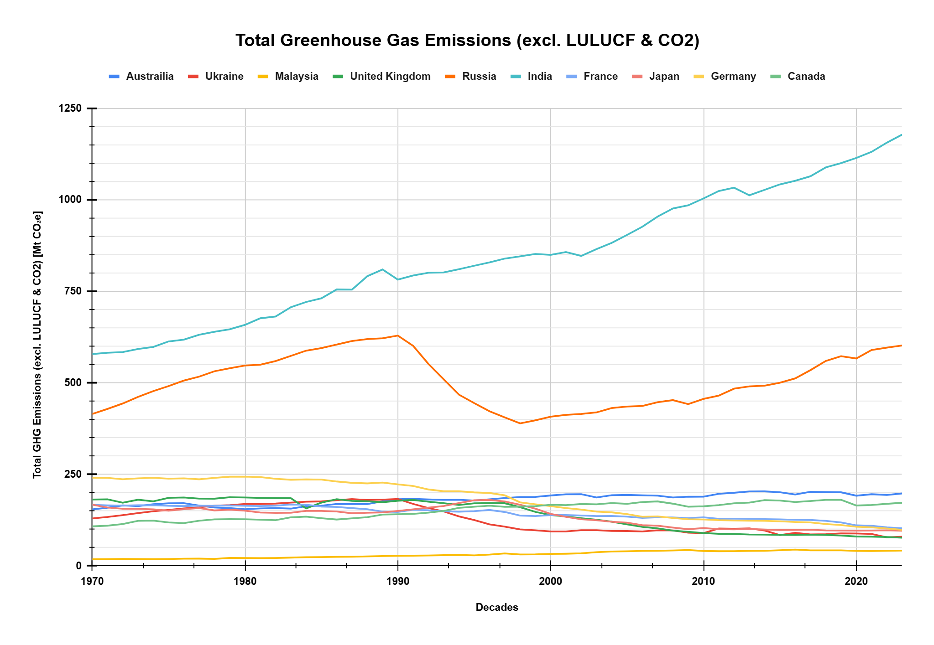

**Other gasses**

|  |  |  |  |
| --- | --- | --- | --- |
| **Country** | **Class 1 (Low)** | **Class 2 (Medium)** | **Class 3 (High)** |
| **Australia** | < 171.437 | 171.437 - 192.052 | > 192.052 |
| **Ukraine** | < 97.3607 | 97.3607- 149.373 | > 149.373 |
| **Malaysia** | < 25.7664 | 25.7664- 40.143 | > 40.143 |
| **United Kingdom** | < 110.222 | 110.222- 175.598 | > 175.598 |
| **Russia** | < 454.716 | 454.716- 547.478 | > 547.478 |
| **India** | < 768.603 | 768.603- 903.925 | > 903.925 |
| **France** | < 133.918 | 133.918- 155.041 | > 155.041 |
| **Japan** | < 114.818 | 114.818- 151.233 | > 151.233 |
| **Germany** | < 138.447 | 138.447- 227.141 | > 227.141 |
| **Canada** | < 134.089 | 134.089- 166.636 | > 166.636 |

# 5.0 RESULTS

## 5.1.1 Australia Gas Emissions (CO2)

|  |  |  |  |  |  |
| --- | --- | --- | --- | --- | --- |
| Years | Emission (mt) | State | Years | Emission (mt) | State |
| 1970 | 160.3769 | Low | 1997 | 322.3709 | Medium |
| 1971 | 162.1077 | Low | 1998 | 342.1087 | Medium |
| 1972 | 167.9569 | Low | 1999 | 348.1127 | Medium |
| 1973 | 177.3185 | Low | 2000 | 353.8697 | Medium |
| 1974 | 186.8463 | Low | 2001 | 360.4081 | Medium |
| 1975 | 193.595 | Low | 2002 | 368.6209 | Medium |
| 1976 | 196.384 | Low | 2003 | 368.115 | Medium |
| 1977 | 209.6638 | Low | 2004 | 381.942 | High |
| 1978 | 205.9886 | Low | 2005 | 384.0857 | High |
| 1979 | 211.8454 | Low | 2006 | 390.1513 | High |
| 1980 | 222.0147 | Low | 2007 | 400.6653 | High |
| 1981 | 222.9747 | Low | 2008 | 404.2851 | High |
| 1982 | 229.2624 | Low | 209 | 410.2594 | High |
| 1983 | 217.7334 | Low | 2010 | 415.2731 | High |
| 1984 | 223.519 | Low | 2011 | 412.8096 | High |
| 1985 | 237.9354 | Low | 2012 | 413.3193 | High |
| 1986 | 238.3953 | Low | 2013 | 405.6523 | High |
| 1987 | 249.5845 | Low | 2014 | 396.2575 | High |
| 1988 | 258.3833 | Medium | 2015 | 400.5424 | High |
| 1989 | 274.1612 | Medium | 2016 | 408.5061 | High |
| 1990 | 277.7123 | Medium | 2017 | 410.8371 | High |
| 1991 | 279.7336 | Medium | 2018 | 409.2067 | High |
| 1992 | 283.1129 | Medium | 2019 | 407.8604 | High |
| 1993 | 287.0239 | Medium | 2020 | 392.5191 | High |
| 1994 | 292.3756 | Medium | 2021 | 384.6772 | High |
| 1995 | 302.6923 | Medium | 2022 | 374.8785 | High |
| 1996 | 312.6713 | Medium | 2023 | 373.6164 | Medium |

Transition of state for Australia Gas Emissions (CO2)

|  |  |
| --- | --- |
| State | Total Transition |
| Low – Low | 17 |
| Low - Medium | 1 |
| Low - High | 0 |
| Medium - Low | 0 |
| Medium – Medium | 15 |
| Medium – High | 1 |
| High – Low | 0 |
| High – Medium | 1 |
| High – High | 18 |

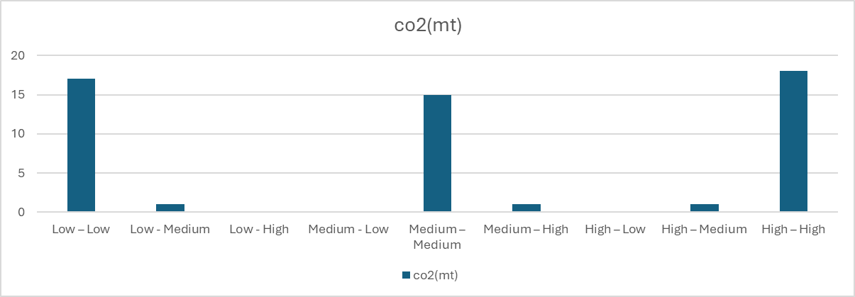

## 5.1.2 Australia Gas Emissions (HFC, PFC, and SF6)

|  |  |  |  |  |  |
| --- | --- | --- | --- | --- | --- |
| Years | Emission (mt) | State | Years | Emission (mt) | State |
| 1970 | 154.65 | Low | 1997 | 185.5247 | Medium |
| 1971 | 159.1969 | Low | 1998 | 188.4313 | Medium |
| 1972 | 165.4939 | Low | 1999 | 188.7807 | Medium |
| 1973 | 163.4756 | Low | 2000 | 192.6407 | High |
| 1974 | 168.628 | Low | 2001 | 195.8103 | High |
| 1975 | 171.2756 | Low | 2002 | 196.2276 | High |
| 1976 | 171.605 | Medium | 2003 | 187.2294 | Medium |
| 1977 | 165.0431 | Low | 2004 | 193.4365 | High |
| 1978 | 159.6786 | Low | 2005 | 194.1612 | High |
| 1979 | 158.0262 | Low | 2006 | 193.1569 | High |
| 1980 | 155.0498 | Low | 2007 | 192.0409 | Medium |
| 1981 | 157.2378 | Low | 2008 | 187.0982 | Medium |
| 1982 | 158.2462 | Low | 209 | 189.2289 | Medium |
| 1983 | 156.773 | Low | 2010 | 189.3309 | Medium |
| 1984 | 163.1264 | Low | 2011 | 197.2203 | High |
| 1985 | 164.6655 | Low | 2012 | 200.0743 | High |
| 1986 | 169.2986 | Low | 2013 | 203.7421 | High |
| 1987 | 169.0553 | Low | 2014 | 203.7756 | High |
| 1988 | 169.0627 | Low | 2015 | 201.516 | High |
| 1989 | 176.6502 | Medium | 2016 | 195.3419 | High |
| 1990 | 182.5836 | Medium | 2017 | 202.5931 | High |
| 1991 | 183.307 | Medium | 2018 | 202.1146 | High |
| 1992 | 181.7357 | Medium | 2019 | 201.3094 | High |
| 1993 | 180.6641 | Medium | 2020 | 192.0524 | High |
| 1994 | 181.0077 | Medium | 2021 | 196.0606 | High |
| 1995 | 178.755 | Medium | 2022 | 194.1318 | High |
| 1996 | 182.1412 | Medium | 2023 | 198.2234 | High |

Transition of state for Australia Gas Emissions (HFC, PFC, and SF6)

|  |  |
| --- | --- |
| State | Total Transition |
| Low – Low | 16 |
| Low - Medium | 2 |
| Low - High | 0 |
| Medium - Low | 1 |
| Medium – Medium | 13 |
| Medium – High | 3 |
| High – Low | 0 |
| High – Medium | 3 |
| High – High | 15 |

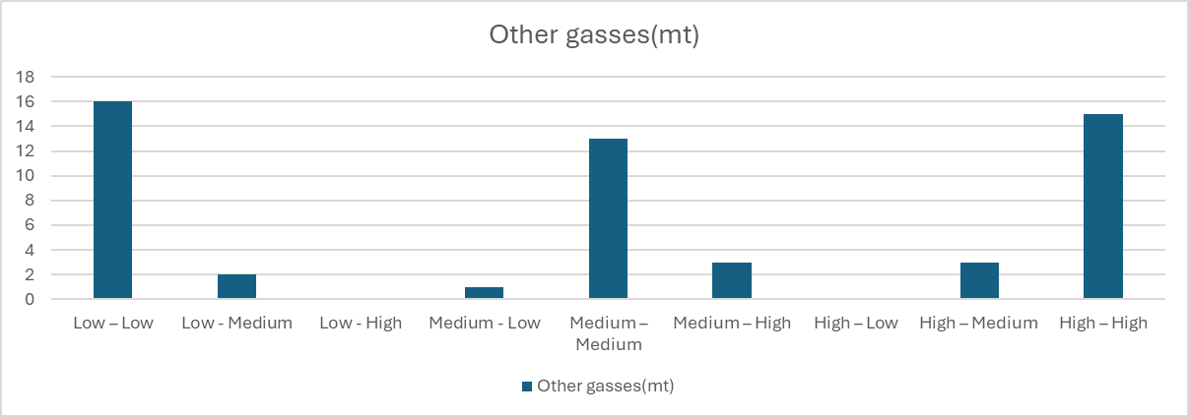

## 5.2.1 Ukraine Gas Emissions (CO2)

|  |  |  |  |  |  |
| --- | --- | --- | --- | --- | --- |
| Years | Emission (mt) | State | Years | Emission (mt) | State |
| 1970 | 477.2242 | Medium | 1997 | 380.9966 | Medium |
| 1971 | 476.8572 | Medium | 1998 | 363.5368 | Medium |
| 1972 | 502.4115 | Medium | 1999 | 363.2923 | Medium |
| 1973 | 532.108 | Medium | 2000 | 360.0221 | Medium |
| 1974 | 556.1456 | Medium | 2001 | 359.0635 | Medium |
| 1975 | 582.1754 | High | 2002 | 359.6469 | Medium |
| 1976 | 600.1396 | High | 2003 | 392.02 | Medium |
| 1977 | 610.5376 | High | 2004 | 367.8053 | Medium |
| 1978 | 653.2175 | High | 2005 | 356.0703 | Low |
| 1979 | 667.0468 | High | 2006 | 355.3087 | Low |
| 1980 | 684.8723 | High | 2007 | 366.3142 | Medium |
| 1981 | 674.3338 | High | 2008 | 350.633 | Low |
| 1982 | 672.4168 | High | 2009 | 290.6597 | Low |
| 1983 | 672.9621 | High | 2010 | 314.3313 | Low |
| 1984 | 676.0755 | High | 2011 | 333.2225 | Low |
| 1985 | 678.3837 | High | 2012 | 324.8218 | Low |
| 1986 | 692.5807 | High | 2013 | 315.1852 | Low |
| 1987 | 713.9627 | High | 2014 | 269.2522 | Low |
| 1988 | 722.0811 | High | 2015 | 226.0362 | Low |
| 1989 | 718.2876 | High | 2016 | 227.1896 | Low |
| 1990 | 785.5447 | High | 2017 | 205.5392 | Low |
| 1991 | 741.0614 | High | 2018 | 218.3518 | Low |
| 1992 | 648.3748 | High | 2019 | 207.8431 | Low |
| 1993 | 565.9997 | High | 2020 | 198.6575 | Low |
| 1994 | 468.4401 | Medium | 2021 | 194.0549 | Low |
| 1995 | 462.6363 | Medium | 2022 | 138.3356 | Low |
| 1996 | 396.2374 | Medium | 2023 | 136.1979 | Low |

Transition of state for Ukraine

|  |  |
| --- | --- |
| State | Total Transition |
| Low – Low | 16 |
| Low - Medium | 1 |
| Low - High | 0 |
| Medium - Low | 2 |
| Medium – Medium | 14 |
| Medium – High | 1 |
| High – Low | 0 |
| High – Medium | 1 |
| High – High | 18 |

## 

## 5.2.2 Ukraine Gas Emissions (HFC, PFC, and SF6)

|  |  |  |  |  |  |
| --- | --- | --- | --- | --- | --- |
| Years | Emission (mt) | State | Years | Emission (mt) | State |
| 1970 | 129.901 | Medium | 1997 | 107.5378 | Medium |
| 1971 | 133.9423 | Medium | 1998 | 99.9512 | Medium |
| 1972 | 139.0019 | Medium | 1999 | 97.5196 | Medium |
| 1973 | 144.4937 | Medium | 2000 | 94.5086 | Low |
| 1974 | 149.3799 | High | 2001 | 94.449 | Low |
| 1975 | 153.1501 | High | 2002 | 97.7823 | Medium |
| 1976 | 157.291 | High | 2003 | 97.8234 | Medium |
| 1977 | 160.3692 | High | 2004 | 95.6097 | Low |
| 1978 | 164.7599 | High | 2005 | 95.5334 | Low |
| 1979 | 166.2948 | High | 2006 | 94.4156 | Low |
| 1980 | 169.5129 | High | 2007 | 97.6094 | Medium |
| 1981 | 169.2835 | High | 2008 | 97.2081 | Low |
| 1982 | 170.5226 | High | 2009 | 90.9627 | Low |
| 1983 | 173.101 | High | 2010 | 89.8381 | Low |
| 1984 | 175.6731 | High | 2011 | 102.5758 | Medium |
| 1985 | 176.4025 | High | 2012 | 101.7328 | Medium |
| 1986 | 179.7917 | High | 2013 | 102.8197 | Medium |
| 1987 | 182.6123 | High | 2014 | 96.8336 | Low |
| 1988 | 180.327 | High | 2015 | 84.5783 | Low |
| 1989 | 181.193 | High | 2016 | 90.6705 | Low |
| 1990 | 182.982 | High | 2017 | 86.4099 | Low |
| 1991 | 169.5441 | High | 2018 | 86.8477 | Low |
| 1992 | 158.3714 | High | 2019 | 89.0123 | Low |
| 1993 | 149.02 | Medium | 2020 | 88.8946 | Low |
| 1994 | 135.4672 | Medium | 2021 | 87.4895 | Low |
| 1995 | 125.5187 | Medium | 2022 | 78.1392 | Low |
| 1996 | 113.7688 | Medium | 2023 | 79.8949 | Low |

Transition of state for Ukraine

|  |  |
| --- | --- |
| State | Total Transition |
| Low – Low | 14 |
| Low - Medium | 3 |
| Low - High | 0 |
| Medium - Low | 4 |
| Medium – Medium | 12 |
| Medium – High | 1 |
| High – Low | 0 |
| High – Medium | 1 |
| High – High | 18 |

## 

## 

## 5.3.1 Malaysia Gas Emissions (CO2)

|  |  |  |  |  |  |
| --- | --- | --- | --- | --- | --- |
| Years | Emission (mt) | State | Years | Emission (mt) | State |
| 1970 | 26.8826 | Low | 1997 | 113.2578 | Medium |
| 1971 | 27.2778 | Low | 1998 | 110.6673 | Medium |
| 1972 | 14.3218 | Low | 1999 | 119.6946 | Medium |
| 1973 | 14.8103 | Low | 2000 | 130.7796 | Medium |
| 1974 | 17.8525 | Low | 2001 | 138.4076 | Medium |
| 1975 | 19.2436 | Low | 2002 | 146.5554 | Medium |
| 1976 | 21.2425 | Low | 2003 | 156.576 | Medium |
| 1977 | 21.1059 | Low | 2004 | 169.6248 | Medium |
| 1978 | 27.1876 | Low | 2005 | 181.1517 | High |
| 1979 | 31.2059 | Low | 2006 | 187.7708 | High |
| 1980 | 32.3916 | Low | 2007 | 204.9404 | High |
| 1981 | 33.0891 | Low | 2008 | 216.1782 | High |
| 1982 | 35.7918 | Low | 2009 | 197.9811 | High |
| 1983 | 41.0466 | Low | 2010 | 215.5746 | High |
| 1984 | 43.1615 | Low | 2011 | 218.3287 | High |
| 1985 | 42.7145 | Low | 2012 | 219.8784 | High |
| 1986 | 43.9599 | Low | 2013 | 237.2457 | High |
| 1987 | 44.7952 | Low | 2014 | 251.4646 | High |
| 1988 | 47.9098 | Medium | 2015 | 252.9286 | High |
| 1989 | 56.6283 | Medium | 2016 | 247.5683 | High |
| 1990 | 64.4223 | Medium | 2017 | 237.8645 | High |
| 1991 | 75.3034 | Medium | 2018 | 254.3612 | High |
| 1992 | 79.2844 | Medium | 2019 | 255.2071 | High |
| 1993 | 79.4983 | Medium | 2020 | 253.3934 | High |
| 1994 | 87.5645 | Medium | 2021 | 258.9144 | High |
| 1995 | 90.9385 | Medium | 2022 | 274.3424 | High |
| 1996 | 103.4302 | Medium | 2023 | 283.3235 | High |

Transition of state for Malaysia

|  |  |
| --- | --- |
| State | Total Transition |
| Low – Low | 17 |
| Low - Medium | 1 |
| Low - High | 0 |
| Medium - Low | 0 |
| Medium – Medium | 16 |
| Medium – High | 1 |
| High – Low | 0 |
| High – Medium | 0 |
| High – High | 18 |

## 

## 5.3.2 Malaysia Gas Emissions (HFC, PFC, and SF6)

|  |  |  |  |  |  |
| --- | --- | --- | --- | --- | --- |
| Years | Emission (mt) | State | Years | Emission (mt) | State |
| 1970 | 18.4245 | Low | 1997 | 34.3581 | Medium |
| 1971 | 18.788 | Low | 1998 | 31.5543 | Medium |
| 1972 | 19.227 | Low | 1999 | 31.8348 | Medium |
| 1973 | 19.0168 | Low | 2000 | 33.1811 | Medium |
| 1974 | 18.6067 | Low | 2001 | 33.5739 | Medium |
| 1975 | 19.1405 | Low | 2002 | 34.6443 | Medium |
| 1976 | 19.9368 | Low | 2003 | 37.8157 | Medium |
| 1977 | 20.1324 | Low | 2004 | 39.6504 | Medium |
| 1978 | 19.3555 | Low | 2005 | 40.1531 | High |
| 1979 | 22.0629 | Low | 2006 | 41.256 | High |
| 1980 | 21.8775 | Low | 2007 | 41.6458 | High |
| 1981 | 21.5365 | Low | 2008 | 42.5089 | High |
| 1982 | 21.8883 | Low | 2009 | 43.5868 | High |
| 1983 | 22.9235 | Low | 2010 | 40.9826 | High |
| 1984 | 23.9781 | Low | 2011 | 40.4037 | High |
| 1985 | 24.3293 | Low | 2012 | 40.5815 | High |
| 1986 | 25.0825 | Low | 2013 | 41.3517 | High |
| 1987 | 25.345 | Low | 2014 | 41.5399 | High |
| 1988 | 26.2049 | Medium | 2015 | 43.117 | High |
| 1989 | 27.1517 | Medium | 2016 | 44.878 | High |
| 1990 | 27.9137 | Medium | 2017 | 42.7179 | High |
| 1991 | 28.2699 | Medium | 2018 | 42.6766 | High |
| 1992 | 28.8354 | Medium | 2019 | 42.6797 | High |
| 1993 | 29.5042 | Medium | 2020 | 41.273 | High |
| 1994 | 30.1376 | Medium | 2021 | 40.8721 | High |
| 1995 | 28.9997 | Medium | 2022 | 41.4461 | High |
| 1996 | 31.1962 | Medium | 2023 | 42.0823 | High |

Transition of state for Malaysia

|  |  |
| --- | --- |
| State | Total Transition |
| Low – Low | 17 |
| Low - Medium | 1 |
| Low - High | 0 |
| Medium - Low | 0 |
| Medium – Medium | 16 |
| Medium – High | 1 |
| High – Low | 0 |
| High – Medium | 0 |
| High – High | 18 |

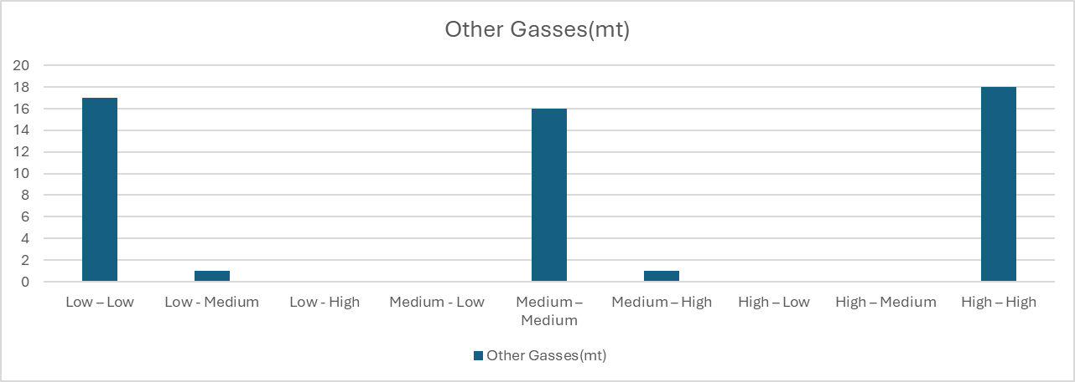

## 5.4.1 United Kingdom Gas Emission (Co2)

|  |  |  |  |  |  |
| --- | --- | --- | --- | --- | --- |
| Years | Emission (mt) | State | Years | Emission (mt) | State |
| 1970 | 673.4202 | High | 1997 | 546.492 | Low |
| 1971 | 668.6714 | High | 1998 | 547.1041 | Medium |
| 1972 | 657.7172 | High | 1999 | 543.7186 | Low |
| 1973 | 690.031 | High | 2000 | 551.6797 | Medium |
| 1974 | 644.6402 | High | 2001 | 562.9085 | Medium |
| 1975 | 623.6572 | High | 2002 | 546.9059 | Medium |
| 1976 | 629.8113 | High | 2003 | 560.427 | Medium |
| 1977 | 638.3125 | High | 2004 | 560.9379 | Medium |
| 1978 | 636.4771 | High | 2005 | 559.3283 | Medium |
| 1979 | 672.6636 | High | 2006 | 559.7568 | Medium |
| 1980 | 608.3254 | High | 2007 | 550.2287 | Medium |
| 1981 | 589.021 | High | 2008 | 533.7479 | Medium |
| 1982 | 573.101 | Medium | 2009 | 483.3614 | Low |
| 1983 | 566.2653 | Medium | 2010 | 500.6285 | Medium |
| 1984 | 549.9603 | Medium | 2011 | 459.0174 | Low |
| 1985 | 576.5427 | Medium | 2012 | 481.19 | Low |
| 1986 | 590.5337 | High | 2013 | 470.1718 | Low |
| 1987 | 595.1847 | High | 2014 | 430.4962 | Low |
| 1988 | 592.8904 | High | 2015 | 415.856 | Low |
| 1989 | 579.2874 | High | 2016 | 393.3439 | Low |
| 1990 | 582.349 | High | 2017 | 381.2854 | Low |
| 1991 | 591.4813 | High | 2018 | 373.2205 | Low |
| 1992 | 578.1824 | High | 2019 | 357.3326 | Low |
| 1993 | 562.1317 | Medium | 2020 | 319.0147 | Low |
| 1994 | 554.6245 | Medium | 2021 | 339.4953 | Low |
| 1995 | 548.0823 | Medium | 2022 | 327.4607 | Low |
| 1996 | 567.3642 | Medium | 2023 | 302.1033 | Low |

Transition of state for United Kingdom

|  |  |
| --- | --- |
| State | Total Transition |
| Low – Low | 12 |
| Low - Medium | 3 |
| Low - High | 0 |
| Medium - Low | 4 |
| Medium – Medium | 14 |
| Medium – High | 1 |
| High – Low | 0 |
| High – Medium | 2 |
| High – High | 17 |

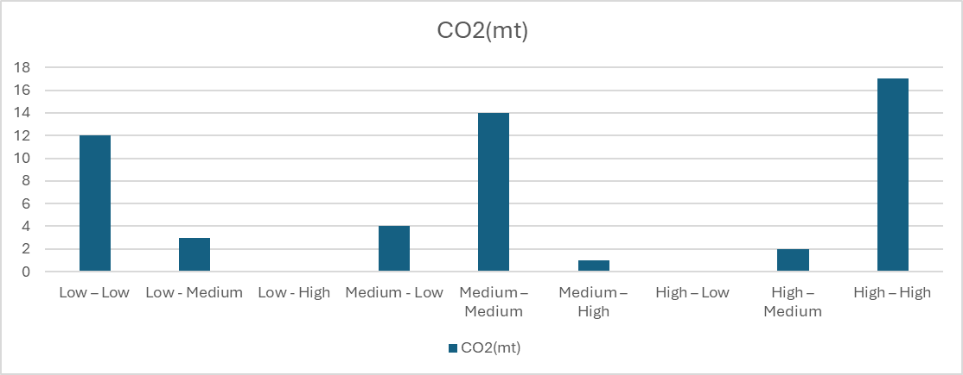

## 5.4.2 United Kingdom Gas Emissions (HFC, PFC, and SF6)

|  |  |  |  |  |  |
| --- | --- | --- | --- | --- | --- |
| Years | Emission (mt) | State | Years | Emission (mt) | State |
| 1970 | 181.6536 | High | 1997 | 171.4073 | Medium |
| 1971 | 182.0735 | High | 1998 | 160.7775 | Medium |
| 1972 | 172.8469 | Medium | 1999 | 147.786 | Medium |
| 1973 | 181.0465 | High | 2000 | 139.3621 | Medium |
| 1974 | 176.5802 | High | 2001 | 135.1786 | Medium |
| 1975 | 186.1481 | High | 2002 | 130.5537 | Medium |
| 1976 | 187.1488 | High | 2003 | 126.3745 | Medium |
| 1977 | 184.0116 | High | 2004 | 121.0078 | Medium |
| 1978 | 183.8887 | High | 2005 | 113.6158 | Low |
| 1979 | 187.7576 | High | 2006 | 106.962 | Low |
| 1980 | 187.2449 | High | 2007 | 102.7328 | Low |
| 1981 | 186.076 | High | 2008 | 96.6763 | Low |
| 1982 | 185.4479 | High | 2009 | 93.3779 | Low |
| 1983 | 185.2091 | High | 2010 | 89.9523 | Low |
| 1984 | 157.3173 | Medium | 2011 | 88.0396 | Low |
| 1985 | 173.1042 | Medium | 2012 | 87.5207 | Low |
| 1986 | 182.5292 | High | 2013 | 86.0478 | Low |
| 1987 | 177.8188 | High | 2014 | 85.6221 | Low |
| 1988 | 176.7544 | High | 2015 | 85.2223 | Low |
| 1989 | 174.2275 | Medium | 2016 | 84.8962 | Low |
| 1990 | 178.2595 | High | 2017 | 85.7573 | Low |
| 1991 | 180.4899 | High | 2018 | 84.9194 | Low |
| 1992 | 175.6261 | High | 2019 | 83.2641 | Low |
| 1993 | 171.5761 | Medium | 2020 | 80.5889 | Low |
| 1994 | 166.5355 | Medium | 2021 | 80.1389 | Low |
| 1995 | 171.2918 | Medium | 2022 | 79.0588 | Low |
| 1996 | 171.8284 | Medium | 2023 | 77.2153 | Low |

|  |  |
| --- | --- |
| State | Total Transition |
| Low – Low | 18 |
| Low - Medium | 0 |
| Low - High | 0 |
| Medium - Low | 1 |
| Medium – Medium | 12 |
| Medium – High | 3 |
| High – Low | 0 |
| High – Medium | 4 |
| High – High | 15 |

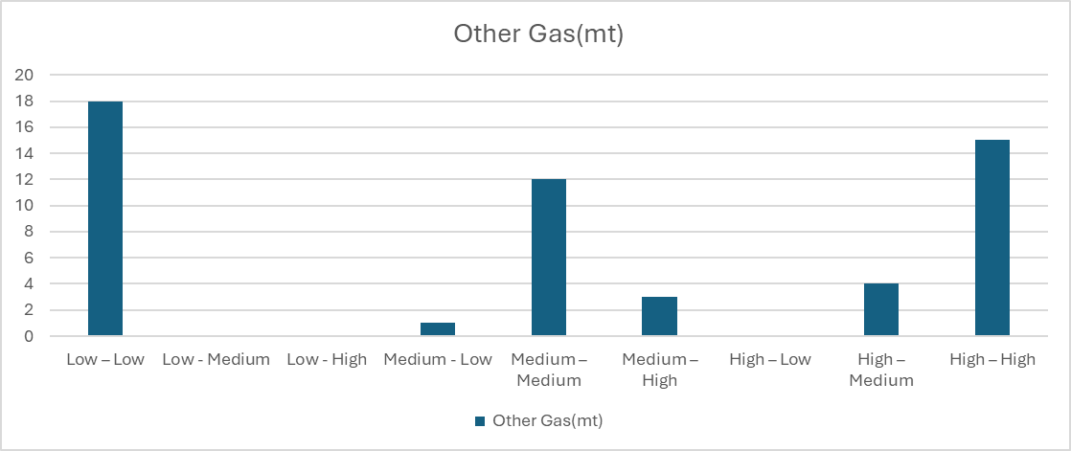

## 5.5.1 Russia Gas Emissions (CO2)

|  |  |  |  |  |  |
| --- | --- | --- | --- | --- | --- |
| Years | Emission (mt) | State | Years | Emission (mt) | State |
| 1970 | 1307.9918 | Low | 1997 | 1604.8446 | Low |
| 1971 | 1308.9747 | Low | 1998 | 1611.1046 | Low |
| 1972 | 1377.0903 | Low | 1999 | 1660.9052 | Low |
| 1973 | 1460.8889 | Low | 2000 | 1681.1439 | Low |
| 1974 | 1536.3042 | Low | 2001 | 1684.2625 | Low |
| 1975 | 1620.8224 | Low | 2002 | 1675.2806 | Low |
| 1976 | 1681.8341 | Low | 2003 | 1737.2379 | Low |
| 1977 | 1719.5681 | Low | 2004 | 1738.8498 | Medium |
| 1978 | 1841.6854 | Medium | 2005 | 1739.2783 | Medium |
| 1979 | 1867.6469 | High | 2006 | 1776.173 | Medium |
| 1980 | 1929.3114 | High | 2007 | 1779.0046 | Medium |
| 1981 | 1923.5418 | High | 2008 | 1764.31 | Medium |
| 1982 | 1951.446 | High | 2009 | 1662.0566 | Medium |
| 1983 | 1985.1133 | High | 2010 | 1746.8481 | Medium |
| 1984 | 2020.4148 | High | 2011 | 1832.562 | Medium |
| 1985 | 2059.49 | High | 2012 | 1819.7501 | Medium |
| 1986 | 2126.7823 | High | 2013 | 1764.1938 | Medium |
| 1987 | 2189.1639 | High | 2014 | 1750.144 | Medium |
| 1988 | 2241.0717 | High | 2015 | 1757.0574 | Medium |
| 1989 | 2252.9505 | High | 2016 | 1734.5602 | Low |
| 1990 | 2436.2592 | High | 2017 | 1763.1528 | Medium |
| 1991 | 2393.5273 | High | 2018 | 1841.4417 | Medium |
| 1992 | 2200.8303 | High | 2019 | 1909.8166 | High |
| 1993 | 2008.7494 | High | 2020 | 1828.7967 | High |
| 1994 | 1811.1206 | Medium | 2021 | 1957.9274 | High |
| 1995 | 1765.1898 | Medium | 2022 | 2025.1436 | High |
| 1996 | 1724.2331 | Low | 2023 | 2069.502 | High |

|  |  |
| --- | --- |
| State | Total Transition |
| Low – Low | 14 |
| Low - Medium | 3 |
| Low - High | 0 |
| Medium - Low | 2 |
| Medium – Medium | 13 |
| Medium – High | 2 |
| High – Low | 0 |
| High – Medium | 1 |
| High – High | 18 |

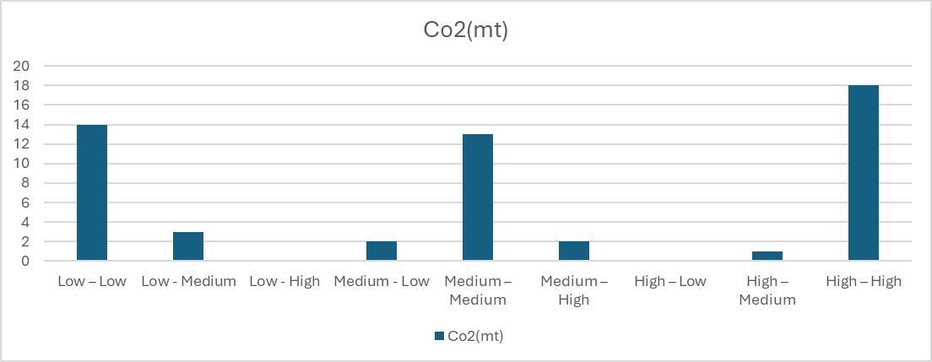

## 5.5.2 Russia Gas Emissions (HFC, PFC, and SF6)

|  |  |  |  |  |  |
| --- | --- | --- | --- | --- | --- |
| Years | Emission (mt) | State | Years | Emission (mt) | State |
| 1970 | 415.1676 | Low | 1997 | 405.8859 | Low |
| 1971 | 428.9727 | Low | 1998 | 389.5317 | Low |
| 1972 | 443.9357 | Low | 1999 | 397.8967 | Low |
| 1973 | 461.7499 | Medium | 2000 | 407.958 | Low |
| 1974 | 477.766 | Medium | 2001 | 412.9241 | Low |
| 1975 | 491.3836 | Medium | 2002 | 415.4149 | Low |
| 1976 | 506.5772 | Medium | 2003 | 419.5637 | Low |
| 1977 | 517.2852 | Medium | 2004 | 431.5988 | Low |
| 1978 | 531.9103 | Medium | 2005 | 435.4624 | Low |
| 1979 | 540.2773 | Medium | 2006 | 437.1168 | Low |
| 1980 | 547.6246 | High | 2007 | 447.2917 | Medium |
| 1981 | 549.8561 | High | 2008 | 453.0917 | Medium |
| 1982 | 559.7154 | High | 2009 | 442.2705 | Low |
| 1983 | 573.9782 | High | 2010 | 456.4066 | Medium |
| 1984 | 588.1578 | High | 2011 | 465.416 | Medium |
| 1985 | 595.2092 | High | 2012 | 484.4093 | Medium |
| 1986 | 604.7923 | High | 2013 | 490.7665 | Medium |
| 1987 | 614.5769 | High | 2014 | 492.5281 | Medium |
| 1988 | 619.8926 | High | 2015 | 500.5797 | Medium |
| 1989 | 622.0119 | High | 2016 | 512.3797 | Medium |
| 1990 | 629.4372 | High | 2017 | 535.0389 | Medium |
| 1991 | 601.4706 | High | 2018 | 560.0525 | High |
| 1992 | 552.0366 | High | 2019 | 573.0174 | High |
| 1993 | 509.8671 | Medium | 2020 | 566.8189 | High |
| 1994 | 468.0081 | Medium | 2021 | 590.028 | High |
| 1995 | 444.8696 | Low | 2022 | 596.3744 | High |
| 1996 | 422.7229 | Low | 2023 | 602.5374 | High |

|  |  |
| --- | --- |
| State | Total Transition |
| Low – Low | 13 |
| Low - Medium | 3 |
| Low - High | 0 |
| Medium - Low | 2 |
| Medium – Medium | 15 |
| Medium – High | 2 |
| High – Low | 0 |
| High – Medium | 1 |
| High – High | 17 |

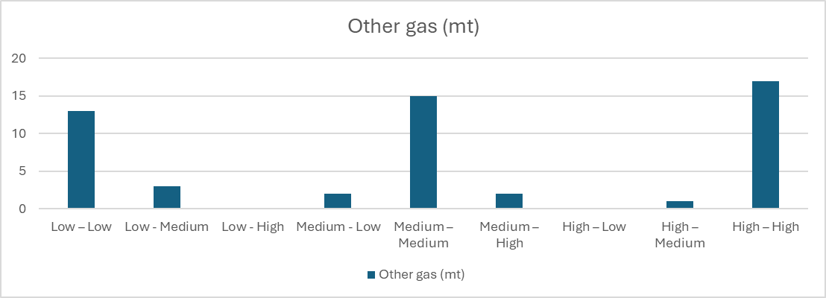

## 5.6.1 India Gas Emissions (CO2)

|  |  |  |  |  |  |
| --- | --- | --- | --- | --- | --- |
| Years | Emission (mt) | State | Years | Emission (mt) | State |
| 1970 | 213.9344 | Low | 1997 | 877.7065 | Medium |
| 1971 | 214.4281 | Low | 1998 | 900.6255 | Medium |
| 1972 | 222.9632 | Low | 1999 | 961.6311 | Medium |
| 1973 | 221.9373 | Low | 2000 | 995.6526 | Medium |
| 1974 | 237.6409 | Low | 2001 | 1011.8047 | Medium |
| 1975 | 253.2017 | Low | 2002 | 1049.8801 | Medium |
| 1976 | 270.6936 | Low | 2003 | 1081.7852 | Medium |
| 1977 | 276.0218 | Low | 2004 | 1166.8166 | Medium |
| 1978 | 271.347 | Low | 2005 | 1216.5339 | High |
| 1979 | 291.7332 | Low | 2006 | 1298.3951 | High |
| 1980 | 303.5765 | Low | 2007 | 1413.8648 | High |
| 1981 | 333.9885 | Low | 2008 | 1503.6111 | High |
| 1982 | 351.9038 | Low | 2009 | 1643.0647 | High |
| 1983 | 374.5973 | Low | 2010 | 1743.6929 | High |
| 1984 | 412.8617 | Low | 2011 | 1850.3319 | High |
| 1985 | 431.4118 | Low | 2012 | 2022.7648 | High |
| 1986 | 468.5979 | Low | 2013 | 2083.2109 | High |
| 1987 | 501.4341 | Low | 2014 | 2242.8409 | High |
| 1988 | 532.2986 | Medium | 2015 | 2260.1314 | High |
| 1989 | 570.1243 | Medium | 2016 | 2303.3619 | High |
| 1990 | 600.6873 | Medium | 2017 | 2433.7831 | High |
| 1991 | 646.3888 | Medium | 2018 | 2573.1194 | High |
| 1992 | 669.6642 | Medium | 2019 | 2542.0351 | High |
| 1993 | 699.7562 | Medium | 2020 | 2318.9477 | High |
| 1994 | 743.8583 | Medium | 2021 | 2548.4833 | High |
| 1995 | 796.4639 | Medium | 2022 | 2740.8206 | High |
| 1996 | 833.512 | Medium | 2023 | 2955.1817 | High |

|  |  |
| --- | --- |
| State | Total Transition |
| Low – Low | 21 |
| Low - Medium | 1 |
| Low - High | 0 |
| Medium - Low | 0 |
| Medium – Medium | 15 |
| Medium – High | 1 |
| High – Low | 0 |
| High – Medium | 0 |
| High – High | 15 |

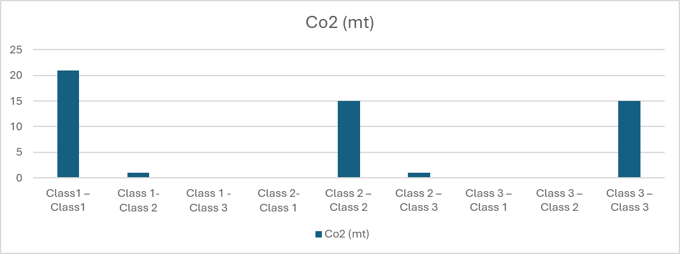

## 5.6.2 India Gas Emissions (HFC, PFC, and SF6)

|  |  |  |  |  |  |
| --- | --- | --- | --- | --- | --- |
| Years | Emission (mt) | State | Years | Emission (mt) | State |
| 1970 | 578.877 | Low | 1997 | 839.7351 | Medium |
| 1971 | 582.3815 | Low | 1998 | 845.8733 | Medium |
| 1972 | 584.2862 | Low | 1999 | 852.2992 | Medium |
| 1973 | 592.6964 | Low | 2000 | 849.7996 | Medium |
| 1974 | 598.3737 | Low | 2001 | 857.5049 | Medium |
| 1975 | 613.4236 | Low | 2002 | 847.0594 | Medium |
| 1976 | 618.3659 | Low | 2003 | 865.4942 | Medium |
| 1977 | 631.677 | Low | 2004 | 882.6749 | Medium |
| 1978 | 639.6889 | Low | 2005 | 904.359 | High |
| 1979 | 646.722 | Low | 2006 | 926.7081 | High |
| 1980 | 658.6685 | Low | 2007 | 954.4633 | High |
| 1981 | 676.6578 | Low | 2008 | 976.5274 | High |
| 1982 | 681.3131 | Low | 2009 | 985.2069 | High |
| 1983 | 706.9399 | Low | 2010 | 1003.9249 | High |
| 1984 | 721.1731 | Low | 2011 | 1024.1499 | High |
| 1985 | 731.2744 | Low | 2012 | 1033.4479 | High |
| 1986 | 755.3699 | Low | 2013 | 1012.7032 | High |
| 1987 | 754.9887 | Low | 2014 | 1027.5293 | High |
| 1988 | 791.5142 | Medium | 2015 | 1042.3562 | High |
| 1989 | 809.869 | Medium | 2016 | 1052.286 | High |
| 1990 | 782.3765 | Medium | 2017 | 1064.619 | High |
| 1991 | 793.3869 | Medium | 2018 | 1088.7464 | High |
| 1992 | 800.9554 | Medium | 2019 | 1100.3753 | High |
| 1993 | 801.9557 | Medium | 2020 | 1114.6713 | High |
| 1994 | 810.7025 | Medium | 2021 | 1131.3785 | High |
| 1995 | 820.1452 | Medium | 2022 | 1156.3884 | High |
| 1996 | 829.2578 | Medium | 2023 | 1178.3727 | High |

|  |  |
| --- | --- |
| State | Total Transition |
| Low – Low | 15 |
| Low - Medium | 1 |
| Low - High | 0 |
| Medium - Low | 0 |
| Medium – Medium | 17 |
| Medium – High | 1 |
| High – Low | 0 |
| High – Medium | 0 |
| High – High | 19 |

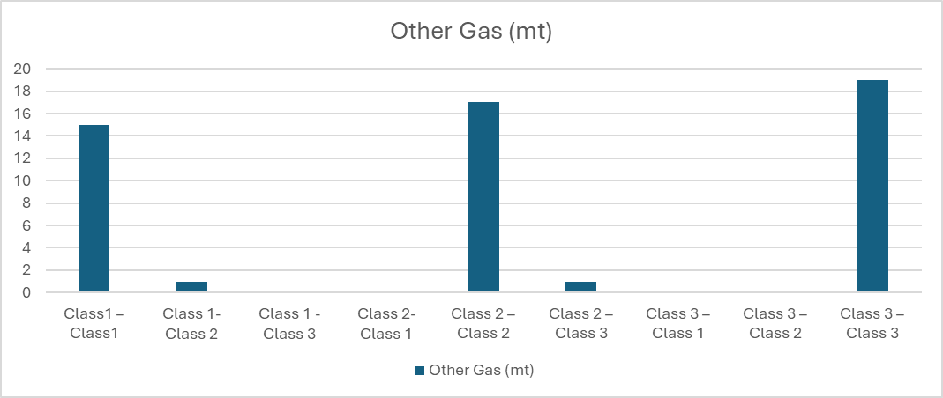

## 5.7.1 France Gas Emissions (CO2)

|  |  |  |  |  |  |
| --- | --- | --- | --- | --- | --- |
| Years | Emission (mt) | State | Years | Emission (mt) | State |
| 1970 | 469.4414 | High | 1997 | 388.4739 | Medium |
| 1971 | 481.5545 | High | 1998 | 410.4713 | High |
| 1972 | 499.1043 | High | 1999 | 404.1642 | Medium |
| 1973 | 535.7473 | High | 2000 | 401.2112 | Medium |
| 1974 | 517.0076 | High | 2001 | 405.3435 | Medium |
| 1975 | 476.4954 | High | 2002 | 399.9106 | Medium |
| 1976 | 521.9985 | High | 2003 | 404.8426 | Medium |
| 1977 | 503.433 | High | 2004 | 405.9175 | Medium |
| 1978 | 521.4465 | High | 2005 | 408.1656 | Medium |
| 1979 | 529.0211 | High | 2006 | 397.4259 | Medium |
| 1980 | 507.05 | High | 2007 | 390.2734 | Medium |
| 1981 | 456.7116 | High | 2008 | 383.0041 | Medium |
| 1982 | 435.6642 | High | 2009 | 370.3759 | Low |
| 1983 | 416.5339 | High | 2010 | 377.7598 | Medium |
| 1984 | 404.9673 | Medium | 2011 | 364.3139 | Low |
| 1985 | 394.7068 | Medium | 2012 | 366.1388 | Low |
| 1986 | 382.601 | Medium | 2013 | 360.9924 | Low |
| 1987 | 375.7727 | Low | 2014 | 328.0879 | Low |
| 1988 | 375.8439 | Low | 2015 | 332.9749 | Low |
| 1989 | 390.36 | Medium | 2016 | 335.7678 | Low |
| 1990 | 385.272 | Medium | 2017 | 339.3458 | Low |
| 1991 | 410.3361 | Medium | 2018 | 328.6302 | Low |
| 1992 | 396.929 | Medium | 2019 | 322.7523 | Low |
| 1993 | 377.283 | Low | 2020 | 287.3243 | Low |
| 1994 | 373.0042 | Low | 2021 | 319.4248 | Low |
| 1995 | 382.0537 | Medium | 2022 | 310.4579 | Low |
| 1996 | 396.7419 | Medium | 2023 | 282.4275 | Low |

|  |  |
| --- | --- |
| State | Total Transition |
| Low – Low | 16 |
| Low - Medium | 2 |
| Low - High | 0 |
| Medium - Low | 3 |
| Medium – Medium | 20 |
| Medium – High | 0 |
| High – Low | 0 |
| High – Medium | 1 |
| High – High | 11 |

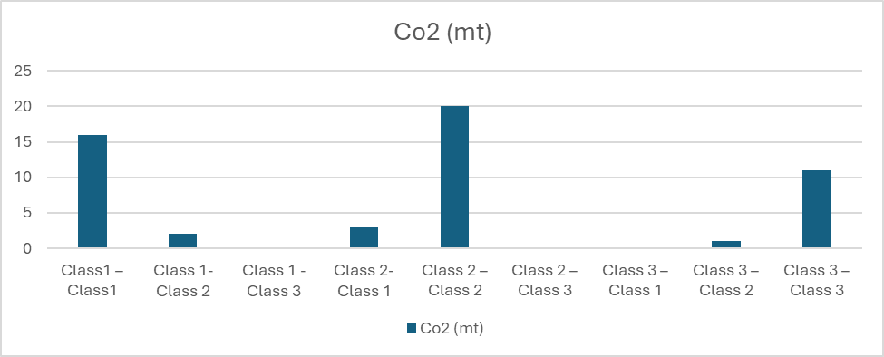

## 5.7.2 France Gas Emissions (HFC, PFC, and SF6)

|  |  |  |  |  |  |
| --- | --- | --- | --- | --- | --- |
| Years | Emission (mt) | State | Years | Emission (mt) | State |
| 1970 | 167.2087 | High | 1997 | 147.4739 | Medium |
| 1971 | 165.7817 | High | 1998 | 137.6944 | Medium |
| 1972 | 164.9418 | High | 1999 | 136.3502 | Medium |
| 1973 | 165.8687 | High | 2000 | 139.0296 | Medium |
| 1974 | 165.9095 | High | 2001 | 139.0718 | Medium |
| 1975 | 164.4412 | High | 2002 | 137.8877 | Medium |
| 1976 | 163.6471 | High | 2003 | 136.3426 | Medium |
| 1977 | 164.7335 | High | 2004 | 136.6046 | Medium |
| 1978 | 164.2727 | High | 2005 | 134.8009 | Medium |
| 1979 | 165.5208 | High | 2006 | 131.5469 | Low |
| 1980 | 164.4991 | High | 2007 | 132.8981 | Low |
| 1981 | 163.7791 | High | 2008 | 132.6107 | Low |
| 1982 | 164.7012 | High | 2009 | 130.7271 | Low |
| 1983 | 168.0553 | High | 2010 | 133.0706 | Low |
| 1984 | 167.5113 | High | 2011 | 128.9305 | Low |
| 1985 | 162.1544 | High | 2012 | 129.2613 | Low |
| 1986 | 161.3396 | High | 2013 | 129.0749 | Low |
| 1987 | 158.0601 | High | 2014 | 128.0805 | Low |
| 1988 | 155.0722 | High | 2015 | 127.4047 | Low |
| 1989 | 148.6831 | Medium | 2016 | 126.1914 | Low |
| 1990 | 147.7418 | Medium | 2017 | 125.673 | Low |
| 1991 | 153.5097 | Medium | 2018 | 123.2398 | Low |
| 1992 | 152.2143 | Medium | 2019 | 118.8784 | Low |
| 1993 | 149.3892 | Medium | 2020 | 111.027 | Low |
| 1994 | 148.1503 | Medium | 2021 | 110.0625 | Low |
| 1995 | 149.7334 | Medium | 2022 | 105.6543 | Low |
| 1996 | 153.0634 | Medium | 2023 | 103.0926 | Low |

|  |  |
| --- | --- |
| State | Total Transition |
| Low – Low | 18 |
| Low - Medium | 0 |
| Low - High | 0 |
| Medium - Low | 1 |
| Medium – Medium | 19 |
| Medium – High | 0 |
| High – Low | 0 |
| High – Medium | 1 |
| High – High | 11 |

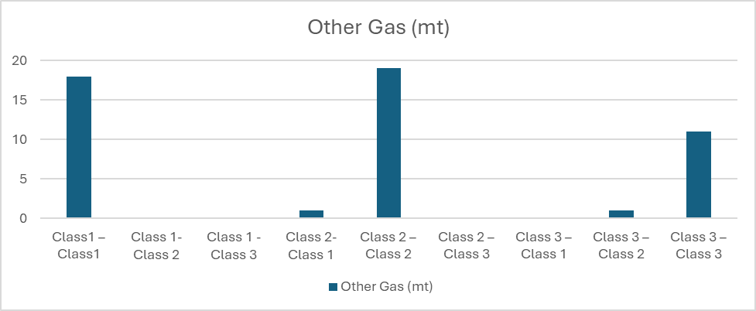

## 5.8.1 Japan Gas Emissions (CO2)

|  |  |  |  |  |  |
| --- | --- | --- | --- | --- | --- |
| Years | Emission (mt) | State | Years | Emission (mt) | State |
| 1970 | 848.7516 | Low | 1997 | 1236.9539 | High |
| 1971 | 846.4521 | Low | 1998 | 1189.7637 | Medium |
| 1972 | 893.0016 | Low | 1999 | 1230.7275 | High |
| 1973 | 1006.6245 | Low | 2000 | 1248.8068 | High |
| 1974 | 1003.1882 | Low | 2001 | 1235.2221 | High |
| 1975 | 948.6801 | Low | 2002 | 1269.4295 | High |
| 1976 | 980.7332 | Low | 2003 | 1276.7113 | High |
| 1977 | 1005.7789 | Low | 2004 | 1271.3841 | High |
| 1978 | 1006.3741 | Low | 2005 | 1283.0176 | High |
| 1979 | 1030.144 | Medium | 2006 | 1260.2992 | High |
| 1980 | 1003.1434 | Low | 2007 | 1296.2507 | High |
| 1981 | 981.5855 | Low | 2008 | 1224.9593 | Medium |
| 1982 | 939.7607 | Low | 2009 | 1161.4121 | Medium |
| 1983 | 943.2447 | Low | 2010 | 1220.4535 | Medium |
| 1984 | 1011.0488 | Medium | 2011 | 1273.3455 | High |
| 1985 | 983.4576 | Low | 2012 | 1311.2998 | High |
| 1986 | 980.48 | Low | 2013 | 1326.7101 | High |
| 1987 | 987.784 | Low | 2014 | 1276.2555 | High |
| 1988 | 1060.6681 | Medium | 2015 | 1235.4187 | High |
| 1989 | 1090.4943 | Medium | 2016 | 1232.8769 | High |
| 1990 | 1166.8237 | Medium | 2017 | 1217.8484 | Medium |
| 1991 | 1176.8604 | Medium | 2018 | 1179.2176 | Medium |
| 1992 | 1181.8812 | Medium | 2019 | 1139.4974 | Medium |
| 1993 | 1174.7455 | Medium | 2020 | 1072.1695 | Medium |
| 1994 | 1227.961 | High | 2021 | 1084.9216 | Medium |
| 1995 | 1238.6398 | High | 2022 | 1009.9787 | Low |
| 1996 | 1251.4624 | High | 2023 | 944.7586 | Low |

|  |  |
| --- | --- |
| State | Total Transition |
| Low – Low | 14 |
| Low - Medium | 3 |
| Low - High | 0 |
| Medium - Low | 3 |
| Medium – Medium | 11 |
| Medium – High | 3 |
| High – Low | 0 |
| High – Medium | 3 |
| High – High | 16 |

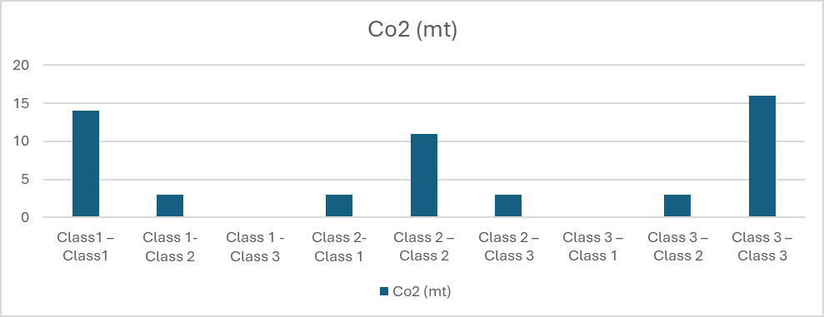

## 5.8.2 Japan Gas Emissions (HFC, PFC, and SF6)

|  |  |  |  |  |  |
| --- | --- | --- | --- | --- | --- |
| Years | Emission (mt) | State | Years | Emission (mt) | State |
| 1970 | 167.5319 | High | 1997 | 176.1504 | High |
| 1971 | 159.7026 | High | 1998 | 167.3727 | High |
| 1972 | 156.2509 | High | 1999 | 156.6843 | High |
| 1973 | 156.1245 | High | 2000 | 142.3145 | Medium |
| 1974 | 154.7456 | High | 2001 | 134.1027 | Medium |
| 1975 | 151.185 | Medium | 2002 | 127.7971 | Medium |
| 1976 | 155.2111 | High | 2003 | 124.8391 | Medium |
| 1977 | 158.1504 | High | 2004 | 120.8039 | Medium |
| 1978 | 151.8672 | High | 2005 | 118.391 | Medium |
| 1979 | 153.8203 | High | 2006 | 111.386 | Low |
| 1980 | 151.2335 | High | 2007 | 110.1283 | Low |
| 1981 | 146.0891 | Medium | 2008 | 105.0733 | Low |
| 1982 | 145.1546 | Medium | 2009 | 100.4963 | Low |
| 1983 | 145.3724 | Medium | 2010 | 103.772 | Low |
| 1984 | 150.5873 | Medium | 2011 | 100.6947 | Low |
| 1985 | 150.4199 | Medium | 2012 | 99.9662 | Low |
| 1986 | 148.9803 | Medium | 2013 | 101.2636 | Low |
| 1987 | 144.0854 | Medium | 2014 | 99.5786 | Low |
| 1988 | 145.5117 | Medium | 2015 | 98.165 | Low |
| 1989 | 146.3412 | Medium | 2016 | 98.4729 | Low |
| 1990 | 150.3943 | Medium | 2017 | 98.9629 | Low |
| 1991 | 154.8085 | High | 2018 | 97.2967 | Low |
| 1992 | 159.5771 | High | 2019 | 96.9947 | Low |
| 1993 | 163.9031 | High | 2020 | 96.5839 | Low |
| 1994 | 171.8252 | High | 2021 | 96.848 | Low |
| 1995 | 179.7094 | High | 2022 | 97.5971 | Low |
| 1996 | 180.4467 | High | 2023 | 96.2542 | Low |

|  |  |
| --- | --- |
| State | Total Transition |
| Low – Low | 17 |
| Low - Medium | 0 |
| Low - High | 0 |
| Medium - Low | 1 |
| Medium – Medium | 14 |
| Medium – High | 2 |
| High – Low | 0 |
| High – Medium | 3 |
| High – High | 16 |

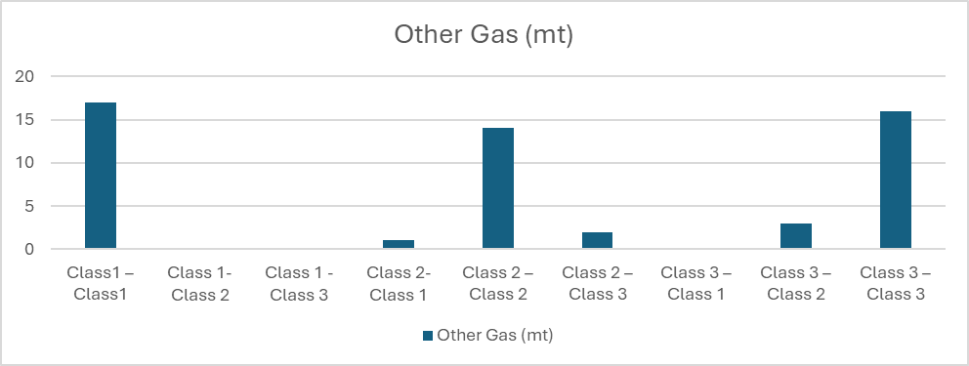

## 5.9.1 Germany Gas Emissions (CO2)

|  |  |  |  |  |  |
| --- | --- | --- | --- | --- | --- |
| Years | Emission (mt) | State | Years | Emission (mt) | State |
| 1970 | 1084.6575 | High | 1997 | 907.821 | Medium |
| 1971 | 1077.4192 | High | 1998 | 906.9508 | Medium |
| 1972 | 1105.2903 | High | 1999 | 871.0236 | Medium |
| 1973 | 1157.7203 | High | 2000 | 871.7357 | Medium |
| 1974 | 1122.5066 | High | 2001 | 885.8183 | Medium |
| 1975 | 1060.5661 | High | 2002 | 870.3116 | Medium |
| 1976 | 1122.9347 | High | 2003 | 878.2763 | Medium |
| 1977 | 1101.4441 | High | 2004 | 863.7247 | Medium |
| 1978 | 1139.317 | High | 2005 | 842.0993 | Low |
| 1979 | 1189.4771 | High | 2006 | 855.8555 | Medium |
| 1980 | 1135.5984 | High | 2007 | 826.9926 | Low |
| 1981 | 1099.9653 | High | 2008 | 830.3551 | Low |
| 1982 | 1054.0401 | High | 2009 | 768.5531 | Low |
| 1983 | 1069.5505 | High | 2010 | 815.3784 | Low |
| 1984 | 1085.7373 | High | 2011 | 788.5477 | Low |
| 1985 | 1086.3402 | High | 2012 | 800.4648 | Low |
| 1986 | 1080.194 | High | 2013 | 818.2784 | Low |
| 1987 | 1072.2524 | High | 2014 | 779.2231 | Low |
| 1988 | 1065.9799 | High | 2015 | 785.3872 | Low |
| 1989 | 1050.769 | Medium | 2016 | 789.7138 | Low |
| 1990 | 1013.0316 | Medium | 2017 | 774.9482 | Low |
| 1991 | 992.0353 | Medium | 2018 | 747.2145 | Low |
| 1992 | 938.1013 | Medium | 2019 | 697.0085 | Low |
| 1993 | 929.647 | Medium | 2020 | 642.552 | Low |
| 1994 | 915.6041 | Medium | 2021 | 677.8039 | Low |
| 1995 | 910.8205 | Medium | 2022 | 659.5018 | Low |
| 1996 | 939.6957 | Medium | 2023 | 582.9506 | Low |

|  |  |
| --- | --- |
| State | Total Transition |
| Low – Low | 16 |
| Low - Medium | 1 |
| Low - High | 0 |
| Medium - Low | 2 |
| Medium – Medium | 15 |
| Medium – High | 0 |
| High – Low | 0 |
| High – Medium | 1 |
| High – High | 18 |

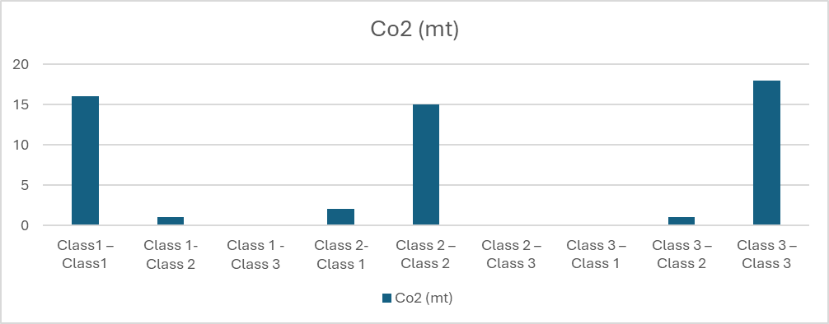

## 5.9.2 Germany Gas Emissions (HFC, PFC, and SF6)

|  |  |  |  |  |  |
| --- | --- | --- | --- | --- | --- |
| Years | Emission (mt) | State | Years | Emission (mt) | State |
| 1970 | 241.174 | High | 1997 | 193.0509 | Medium |
| 1971 | 240.7372 | High | 1998 | 173.9074 | Medium |
| 1972 | 237.0205 | High | 1999 | 168.4669 | Medium |
| 1973 | 239.5346 | High | 2000 | 163.6426 | Medium |
| 1974 | 240.9663 | High | 2001 | 158.1728 | Medium |
| 1975 | 238.6106 | High | 2002 | 154.1477 | Medium |
| 1976 | 239.3703 | High | 2003 | 148.6754 | Medium |
| 1977 | 236.7816 | High | 2004 | 146.5313 | Medium |
| 1978 | 240.6494 | High | 2005 | 141.5988 | Medium |
| 1979 | 243.983 | High | 2006 | 134.5138 | Low |
| 1980 | 244.2057 | High | 2007 | 135.4187 | Low |
| 1981 | 242.8523 | High | 2008 | 131.1995 | Low |
| 1982 | 238.1827 | High | 2009 | 127.7435 | Low |
| 1983 | 235.5819 | High | 2010 | 127.148 | Low |
| 1984 | 236.4631 | High | 2011 | 125.1735 | Low |
| 1985 | 236.048 | High | 2012 | 124.2622 | Low |
| 1986 | 230.8689 | High | 2013 | 123.6365 | Low |
| 1987 | 227.1727 | High | 2014 | 123.3072 | Low |
| 1988 | 225.5768 | Medium | 2015 | 122.1329 | Low |
| 1989 | 227.8454 | High | 2016 | 120.3045 | Low |
| 1990 | 222.8419 | Medium | 2017 | 118.9422 | Low |
| 1991 | 218.5519 | Medium | 2018 | 114.6747 | Low |
| 1992 | 209.0949 | Medium | 2019 | 111.7812 | Low |
| 1993 | 204.1167 | Medium | 2020 | 107.2477 | Low |
| 1994 | 204.3024 | Medium | 2021 | 105.6847 | Low |
| 1995 | 201.0475 | Medium | 2022 | 102.4817 | Low |
| 1996 | 199.4715 | Medium | 2023 | 98.8597 | Low |

|  |  |
| --- | --- |
| State | Total Transition |
| Low – Low | 17 |
| Low - Medium | 0 |
| Low - High | 0 |
| Medium - Low | 1 |
| Medium – Medium | 15 |
| Medium – High | 1 |
| High – Low | 0 |
| High – Medium | 2 |
| High – High | 17 |

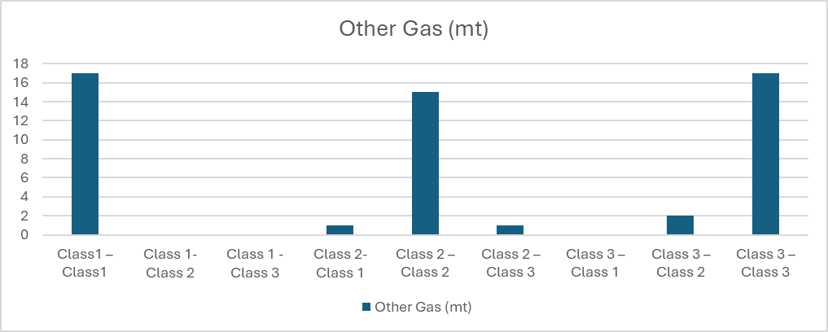

## 5.10.1 Canada Gas Emissions (CO2)

|  |  |  |  |  |  |
| --- | --- | --- | --- | --- | --- |
| Years | Emission (mt) | State | Years | Emission (mt) | State |
| 1970 | 358.1272 | Low | 1997 | 505.6071 | Medium |
| 1971 | 365.7851 | Low | 1998 | 513.8019 | Medium |
| 1972 | 383.0355 | Low | 1999 | 523.3953 | Medium |
| 1973 | 401.9821 | Low | 2000 | 543.0448 | Medium |
| 1974 | 410.0579 | Low | 2001 | 534.3097 | Medium |
| 1975 | 400.2143 | Low | 2002 | 554.0309 | Medium |
| 1976 | 413.3629 | Low | 2003 | 573.6839 | High |
| 1977 | 427.8718 | Low | 2004 | 559.7293 | High |
| 1978 | 431.0299 | Low | 2005 | 581.0957 | High |
| 1979 | 445.1962 | Medium | 2006 | 573.5411 | High |
| 1980 | 450.4307 | Medium | 2007 | 594.0202 | High |
| 1981 | 431.7735 | Low | 2008 | 574.5625 | High |
| 1982 | 413.774 | Low | 2009 | 541.8042 | Medium |
| 1983 | 407.4239 | Low | 2010 | 561.6033 | High |
| 1984 | 426.7784 | Low | 2011 | 575.8915 | High |
| 1985 | 426.65 | Low | 2012 | 567.2705 | High |
| 1986 | 416.5804 | Low | 2013 | 575.2453 | High |
| 1987 | 429.3182 | Low | 2014 | 580.4828 | High |
| 1988 | 460.3398 | Medium | 2015 | 577.1296 | High |
| 1989 | 475.4707 | Medium | 2016 | 575.8711 | High |
| 1990 | 440.4753 | Low | 2017 | 593.0442 | High |
| 1991 | 434.5216 | Low | 2018 | 613.6582 | High |
| 1992 | 447.282 | Medium | 2019 | 607.2496 | High |
| 1993 | 446.6273 | Medium | 2020 | 546.6751 | Medium |
| 1994 | 463.8531 | Medium | 2021 | 561.6259 | High |
| 1995 | 475.9147 | Medium | 2022 | 575.3213 | High |
| 1996 | 489.835 | Medium | 2023 | 575.012 | High |

|  |  |
| --- | --- |
| Class | Total Transition |
| Low – Low | 15 |
| Low - Medium | 3 |
| Low - High | 0 |
| Medium - Low | 2 |
| Medium – Medium | 12 |
| Medium – High | 3 |
| High – Low | 0 |
| High – Medium | 2 |
| High – High | 16 |

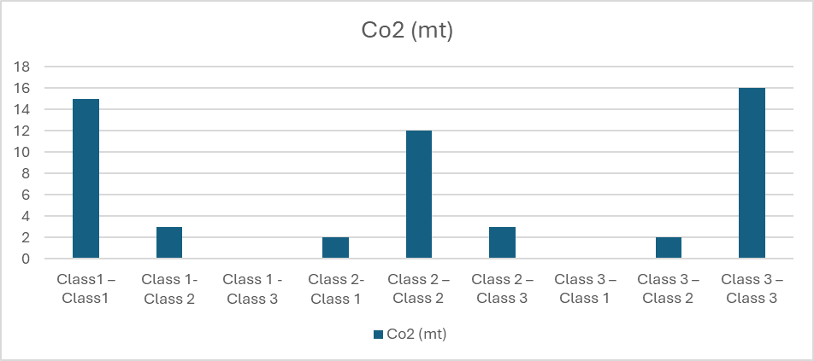

## 5.10.2 Canada Gas Emissions (HFC, PFC, and SF6)

|  |  |  |  |  |  |
| --- | --- | --- | --- | --- | --- |
| Years | Emission (mt) | State | Years | Emission (mt) | State |
| 1970 | 108.2327 | Low | 1997 | 161.5945 | Medium |
| 1971 | 110.111 | Low | 1998 | 162.069 | Medium |
| 1972 | 114.7027 | Low | 1999 | 163.4276 | Medium |
| 1973 | 123.3336 | Low | 2000 | 167.3287 | High |
| 1974 | 124.0506 | Low | 2001 | 166.3117 | Medium |
| 1975 | 118.9361 | Low | 2002 | 169.2873 | High |
| 1976 | 117.2138 | Low | 2003 | 168.5628 | High |
| 1977 | 123.783 | Low | 2004 | 171.8509 | High |
| 1978 | 127.4291 | Low | 2005 | 169.8527 | High |
| 1979 | 127.8604 | Low | 2006 | 174.6697 | High |
| 1980 | 127.7925 | Low | 2007 | 176.3821 | High |
| 1981 | 126.3566 | Low | 2008 | 170.2017 | High |
| 1982 | 125.2788 | Low | 2009 | 162.0224 | Medium |
| 1983 | 132.8871 | Low | 2010 | 163.0218 | Medium |
| 1984 | 134.8529 | Medium | 2011 | 166.3552 | Medium |
| 1985 | 130.5435 | Low | 2012 | 171.2035 | High |
| 1986 | 126.9778 | Low | 2013 | 173.1763 | High |
| 1987 | 130.2512 | Low | 2014 | 179.9368 | High |
| 1988 | 133.3558 | Low | 2015 | 178.7761 | High |
| 1989 | 140.4354 | Medium | 2016 | 174.7298 | High |
| 1990 | 141.4375 | Medium | 2017 | 177.4325 | High |
| 1991 | 142.3277 | Medium | 2018 | 180.5155 | High |
| 1992 | 145.8409 | Medium | 2019 | 180.7581 | High |
| 1993 | 150.4697 | Medium | 2020 | 165.2562 | Medium |
| 1994 | 158.9438 | Medium | 2021 | 166.642 | High |
| 1995 | 161.9299 | Medium | 2022 | 169.9238 | High |
| 1996 | 164.8088 | Medium | 2023 | 172.666 | High |

|  |  |
| --- | --- |
| Class | Total Transition |
| Low – Low | 16 |
| Low - Medium | 2 |
| Low - High | 0 |
| Medium - Low | 1 |
| Medium – Medium | 12 |
| Medium – High | 4 |
| High – Low | 0 |
| High – Medium | 3 |
| High – High | 15 |

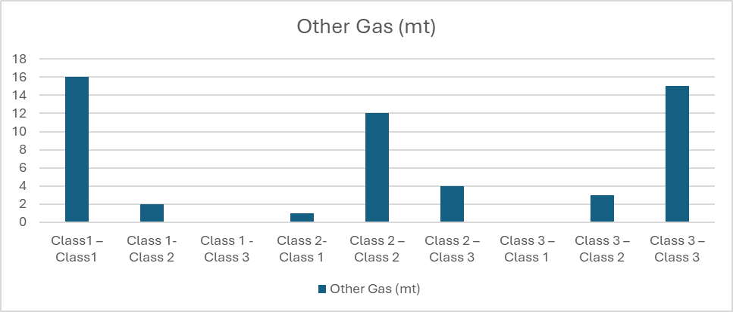

## 6.0 RESULT ANALYSIS

## 6.1 Which Country Is Contributing More to Climate Changing

**Analysis of your results/output from your chosen method(s) Markov, Discrete Dynamic System, Least Square, Game Theory, Optimisation:**

**Australia co2  
Class 1 (Low)**

* Total from Class 1 = 17 (to Low) + 1 (to Medium) + 0 (to High) = 18
* Low – Low = 17 / 18 = 0.9444
* Low – Medium = 1 / 18 = 0.0556
* Low - High= 0 / 18 = 0

**Class 2 (Medium)**

* Total from Class 2 = 0 (to Low) + 15 (to Medium) + 1 (to High) = 16
* Medium - Low= 0 / 16 = 0
* Medium – Medium = 15 / 16 = 0.9375
* Medium – High = 1 / 16 = 0.0625

**Class 3 (High)**

* Total from Class 3 = 0 (to Low) + 1 (to Medium) + 18 (to High) = 19
* High – Low = 0 / 19 = 0
* High – Medium = 1 / 19 = 0.0526
* High - High = 18 / 19 = 0.9474

**Transition Matrix**

|  |  |  |  |
| --- | --- | --- | --- |
|  | **Low** | **Medium** | **High** |
| **Low** | 0.9444 | 0 | 0 |
| **Medium** | 0.0556 | 0.9375 | 0.0526 |
| **High** | 0 | 0.0625 | 0.9474 |

**Eigenvalues (rounded):** [1.0000 0.8849 0.9444]

**Eigenvectors (rounded):**

[[ 0.00 0.00 0.69 ]  
 [ 0.64 0.71 0.03 ]  
 [ 0.77 -0.71 -0.72 ]]

**Steady-State Probabilities:** [0.00 0.45 0.55] **Convergence Time (years):** 53.0 **Verification (Pπ ≈ π):** True

In the long run, there is a 45.00% chance that CO₂ and other gas emissions in Australia will remain at a moderate level, and a 55.00% chance that they will reach a high level, with almost no likelihood of staying at a low level.

**Ukraine – CO₂  
Class 1 (Low)**

* Total from Class 1 = 16 (to Low) + 1 (to Medium) + 0 (to High) = 17
* Low - Low = 16/17 = 0.9412
* Low - Medium = 1/17 = 0.0588
* Low - High = 0/17 = 0

**Class 2 (Medium)**

* Total from Class 2 = 2 (to Low) + 14 (to Medium) + 1 (to High) = 17
* Medium - Low = 2/17 = 0.1176
* Medium - Medium = 14/17 = 0.8235
* Medium - High = 1/17 = 0.0588

**Class 3 (High)**

* Total from Class 3 = 0 (to Low) + 1 (to Medium) + 18 (to High) = 19
* High - Low = 0/19 = 0
* High - Medium = 1/19 = 0.0526
* High - High = 18/19 = 0.9474

**Transition Matrix**

|  |  |  |  |
| --- | --- | --- | --- |
|  | **Low** | **Medium** | **High** |
| **Low** | 0.9412 | 0.1176 | 0 |
| **Medium** | 0.0588 | 0.8235 | 0.0526 |
| **High** | 0 | 0.0588 | 0.9474 |

**Eigenvalues (rounded):** [0.7667 1.000 0.9454]

**Eigenvectors (rounded):** [[ 0.54 0.8 -0.69 ]  
 [ -0.8 0.4 -0.02 ]  
 [ 0.26 0.45 0.72 ]]

**Steady-State Probabilities:** [0.48 0.24 0.27]  
**Convergence Time (years):** 54.0  
**Verification (Pπ ≈ π):** True

In the long run, there is a 48.00% chance that CO₂ emissions in Ukraine will remain at a low level, a 24.00% chance of stabilizing at a medium level, and a 27.00% chance of persisting at a high level.

**Malaysia – CO₂  
Class 1 (Low)**

* Total from Class 1 = 17 (to Low) + 1 (to Medium) + 0 (to High) = 18
* Low - Low = 17/18 = 0.9444
* Low - Medium = 1/18 = 0.0556
* Low - High = 0/18 = 0

**Class 2 (Medium)**

* Total from Class 2 = 0 (to Low) + 16 (to Medium) + 1 (to High) = 17
* Medium - Low = 0/17 = 0
* Medium - Medium = 16/17 = 0.9412
* Medium - High = 1/17 = 0.0588

**Class 3 (High)**

* Total from Class 3 = 0 (to Low) + 0 (to Medium) + 18 (to High) = 18
* High - Low = 0/18 = 0
* High - Medium = 0/18 = 0
* High - High = 18/18 = 1.0

**Transition Matrix**

|  |  |  |  |
| --- | --- | --- | --- |
|  | **Low** | **Medium** | **High** |
| **Low** | 0.9444 | 0.0 | 0.0 |
| **Medium** | 0.0556 | 0.9412 | 0.0 |
| **High** | 0.0 | 0.0588 | 1.0 |

**Eigenvalues (rounded):** [1.0000 0.9412 0.9444]

**Eigenvectors (rounded):**

[[ 0.00 0.00 0.04 ]  
 [ 0.00 0.71 0.69 ]  
 [ 1.00 -0.71 -0.73 ]]

**Steady-State Probabilities:** [0.00 0.00 1.0] **Convergence Time (years):** 53.0 **Verification (Pπ ≈ π):** True

Gas emissions are projected to ultimately stabilize in the high state. The steady-state distribution [0, 0, 1] confirms that, over time, all probability mass accumulates in the high-emission state, making it an absorbing state. This suggests that without intervention, emission levels will become permanently high.

**United Kingdom – CO₂**

**Class 1 (Low)**

* Total from Class 1 = 12 (to Low) + 3 (to Medium) + 0 (to High) = 15
* Low - Low = 12/15 = 0.8
* Low - Medium = 3/15 = 0.2
* Low - High = 0/15 = 0

**Class 2 (Medium)**

* Total from Class 2 = 4 (to Low) + 14 (to Medium) + 1 (to High) = 19
* Medium - Low = 4/19 = 0.2105
* Medium - Medium = 14/19 = 0.7368
* Medium - High = 1/19 = 0.0526

**Class 3 (High)**

* Total from Class 3 = 0 (to Low) + 2 (to Medium) + 17 (to High) = 19
* High - Low = 0/19 = 0
* High - Medium = 2/19 = 0.1053
* High - High = 17/19 = 0.8947

Transition Matrix

|  |  |  |  |
| --- | --- | --- | --- |
|  | **Low** | **Medium** | **High** |
| **Low** | 0.8 | 0.2105 | 0.0 |
| **Medium** | 0.2 | 0.7368 | 0.1053 |
| **High** | 0.0 | 0.0526 | 0.8947 |

**Eigenvalues (rounded):** [0.5514 1.0000 0.8802]

**Eigenvectors (rounded):** [[ 0.64 0.69 -0.57]  
 [-0.76 0.65 -0.22]  
 [ 0.12 0.33 0.79]]

**Steady-State Probabilities:** [0.41 0.39 0.20 ]

**Convergence Time (years):** 24.0

**Verification (Pπ ≈ π):** True

In the long run, there is a 41.00% chance that CO₂ emissions in the United Kingdom will remain at a low level, a 39.00% chance of stabilizing at a medium level, and a 20.00% chance of persisting at a high level.

**Russia – CO₂**

**Class 1 (Low)**

* Total from Class 1 = 14 (to Low) + 3 (to Medium) + 0 (to High) = 17
* Low - Low = 14/17 = 0.8235
* Low - Medium = 3/17 = 0.1765
* Low - High = 0/17 = 0

**Class 2 (Medium)**

* Total from Class 2 = 2 (to Low) + 13 (to Medium) + 2 (to High) = 17
* Medium - Low = 2/17 = 0.1176
* Medium - Medium = 13/17 = 0.7647
* Medium - High = 2/17 = 0.1176

**Class 3 (High)**

* Total from Class 3 = 0 (to Low) + 1 (to Medium) + 18 (to High) = 19
* High - Low = 0/19 = 0
* High - Medium = 1/19 = 0.0526
* High - High = 18/19 = 0.9474

**Transition Matrix**

|  |  |  |  |
| --- | --- | --- | --- |
|  | **Low** | **Medium** | **High** |
| **Low** | 0.8 | 0.2105 | 0.0 |
| **Medium** | 0.2 | 0.7368 | 0.1053 |
| **High** | 0.0 | 0.0526 | 0.8947 |

**Eigenvalues (rounded):** [0.6349 0.9008 1.0000 ]

**Eigenvectors (rounded):**

[[ 0.5 0.49 0.26 ]  
 [ -0.81 0.32 0.39 ]  
 [ 0.3 -0.81 0.88 ] ]

**Steady-State Probabilities:** [0.17 0.25 0.58]

**Convergence Time (years)**: 29.0

**Verification (Pπ ≈ π):** True

In the long run, there is a 17% probability that Russia’s annual CO₂ emissions will remain in the Low state, a 25% probability of remaining in the Medium state, and a 58% probability of staying in the High emission state. This steady-state distribution suggests that, without intervention, Russia is more likely to experience persistently high levels of CO₂ emissions in the future.

**India – CO₂**

**Class 1 (Low)**

* Total from Class 1 = 21 (to Low) + 1 (to Medium) + 0 (to High) = 22
* Low - Low = 21/22 = 0.9545
* Low - Medium = 1/22 = 0.0455
* Low - High = 0/22 = 0

**Class 2 (Medium)**

* Total from Class 2 = 0 (to Low) + 15 (to Medium) + 1 (to High) = 16
* Medium - Low = 0/16 = 0
* Medium - Medium = 15/16 = 0.9375
* Medium - High = 1/16 = 0.0625

**Class 3 (High)**

* Total from Class 3 = 0 (to Low) + 0 (to Medium) + 15 (to High) = 15
* High - Low = 0/15 = 0
* High - Medium = 0/15 = 0
* High - High = 15/15 = 1.0

Transition Matrix

|  |  |  |  |
| --- | --- | --- | --- |
|  | Low | Medium | High |
| Low | 0.9545 | 0.0 | 0.0 |
| Medium | 0.0455 | 0.9375 | 0.0 |
| High | 0.0 | 0.0625 | 1.0 |

**Eigenvalues (rounded):** [1. 000 0.9375 0.9545]

**Eigenvectors (rounded):**

[[ 0.0 0.0 0.21]

[ 0.0 0.71 0.57]

[ 1.0 -0.71 -0.79]]

**Steady-State Probabilities:** [0. 0. 1.]

**Convergence Time (years)**: 65.0

**Verification (Pπ ≈ π)**: True

Gas emissions are projected to ultimately stabilize in the high state. The steady-state distribution [0, 0, 1] confirms that, over time, all probability mass accumulates in the high-emission state, making it an absorbing state. This suggests that without intervention, emission levels will become permanently high.

**France – CO₂**

**Class 1 (Low)**

* Total from Class 1 = 16 (to Low) + 2 (to Medium) + 0 (to High) = 18
* Low - Low = 16/18 = 0.8889
* Low - Medium = 2/18 = 0.1111
* Low - High = 0/18 = 0

**Class 2 (Medium)**

* Total from Class 2 = 3 (to Low) + 20 (to Medium) + 0 (to High) = 23
* Medium - Low = 3/23 = 0.1304
* Medium - Medium = 20/23 = 0.8696
* Medium - High = 0/23 = 0

**Class 3 (High)**

* Total from Class 3 = 0 (to Low) + 1 (to Medium) + 11 (to High) = 12
* High - Low = 0/12 = 0
* High - Medium = 1/12 = 0.0833
* High - High = 11/12 = 0.9167

Transition Matrix

|  |  |  |  |
| --- | --- | --- | --- |
|  | Low | Medium | High |
| Low | 0.8889 | 0.1304 | 0.0 |
| Medium | 0.1111 | 0.8696 | 0.0833 |
| High | 0.0 | 0.0 | 0.9167 |

**Eigenvalues (rounded):** [1. 0 0.7585 0.9167]

**Eigenvectors (rounded):**

[[ 0.76 -0.71 -0.63]

[ 0.65 0.71 -0.13]

[ 0.00 0.00 0.76]]

**Steady-State Probabilities:** [0.54 0.46 0.00 ]

**Convergence Time (years):** 35.0

**Verification (Pπ ≈ π):** True

In the long run, there is a 54% probability that France’s annual CO₂ emissions will remain in the Low state,and a 46% probability of remaining in the Medium state. This steady-state distribution suggests that, without intervention, France is more likely to experience persistently low levels of CO₂ emissions in the future.

**Japan – CO₂**

**Class 1 (Low)**

* Total from Class 1 = 14 (to Low) + 3 (to Medium) + 0 (to High) = 17
* Low - Low = 14/17 = 0.8235
* Low - Medium = 3/17 = 0.1765
* Low - High = 0/17 = 0

**Class 2 (Medium)**

* Total from Class 2 = 3 (to Low) + 11 (to Medium) + 3 (to High) = 17
* Medium - Low = 3/17 = 0.1765
* Medium - Medium = 11/17 = 0.6471
* Medium - High = 3/17 = 0.1765

**Class 3 (High)**

* Total from Class 3 = 0 (to Low) + 3 (to Medium) + 16 (to High) = 19
* High - Low = 0/19 = 0
* High - Medium = 3/19 = 0.1579
* High - High = 16/19 = 0.8421

Transition Matrix

|  |  |  |  |
| --- | --- | --- | --- |
|  | Low | Medium | High |
| Low | 0.8235 | 0.1765 | 0.0 |
| Medium | 0.1765 | 0.6471 | 0.1579 |
| High | 0.0 | 0.1765 | 0.8421 |

**Eigenvalues (rounded):** [0.4796 0.833 1.00 ]

**Eigenvectors (rounded):**

[[ 0.42 0.69 0.55]

[-0.82 0.04 0.55]

[ 0.4 -0.72 0.62]]

**Steady-State Probabilities:** [0.32 0.32 0.36]

**Convergence Time (years)**: 17.0

**Verification (Pπ ≈ π):** True

In the long run, there is a 32% probability that Japan’s annual CO₂ emissions will remain in the Low state, a 32% probability of remaining in the Medium state, and a 36% probability of staying in the High emission state. This steady-state distribution suggests that, without intervention, Japan is more likely to experience persistently high levels of CO₂ emissions in the future.

**Germany – CO₂**

**Class 1 (Low)**

* Total from Class 1 = 16 (to Low) + 1 (to Medium) + 0 (to High) = 17
* Low - Low = 16/17 = 0.9412
* Low - Medium = 1/17 = 0.0588
* Low - High = 0/17 = 0

**Class 2 (Medium)**

* Total from Class 2 = 2 (to Low) + 15 (to Medium) + 0 (to High) = 17
* Medium - Low = 2/17 = 0.1176
* Medium - Medium = 15/17 = 0.8824
* Medium - High = 0/17 = 0

**Class 3 (High)**

* Total from Class 3 = 0 (to Low) + 1 (to Medium) + 18 (to High) = 19
* High - Low = 0/19 = 0
* High - Medium = 1/19 = 0.0526
* High - High = 18/19 = 0.9474

Transition Matrix

|  |  |  |  |
| --- | --- | --- | --- |
|  | Low | Medium | High |
| Low | 0.9412 | 0.1176 | 0.0 |
| Medium | 0.0588 | 0.8824 | 0.0536 |
| High | 0.0 | 0.0 | 0.9474 |

**Eigenvalues (rounded):** [1. 0 0.8236 0.9474]

**Eigenvectors (rounded):**

[[ 0.89 -0.71 -0.69]

[ 0.45 0.71 -0.04]

[ 0. 00 0.00 0.72]]

**Steady-State Probabilities:** [0.66 0.34 0.00 ]

**Convergence Time (years):** 56.0

**Verification (Pπ ≈ π):** True

In the long run, there is a 64% probability that Germany’s annual CO₂ emissions will remain in the Low state, and a 34% probability of remaining in the Medium state. This steady-state distribution suggests that, without intervention, Germany is more likely to experience persistently low levels of CO₂ emissions in the future.

**Canada – CO₂**

**Class 1 (Low)**

* Total from Class 1 = 15 (to Low) + 3 (to Medium) + 0 (to High) = 18
* Low - Low = 15/18 = 0.8333
* Low - Medium = 3/18 = 0.1667
* Low - High = 0/18 = 0

**Class 2 (Medium)**

* Total from Class 2 = 2 (to Low) + 12 (to Medium) + 3 (to High) = 17
* Medium - Low = 2/17 = 0.1176
* Medium - Medium = 12/17 = 0.7059
* Medium - High = 3/17 = 0.1765

**Class 3 (High)**

* Total from Class 3 = 0 (to Low) + 2 (to Medium) + 16 (to High) = 18
* High - Low = 0/18 = 0
* High - Medium = 2/18 = 0.1111
* High - High = 16/18 = 0.8889

Transition Matrix

|  |  |  |  |
| --- | --- | --- | --- |
|  | Low | Medium | High |
| Low | 0.8333 | 0.1176 | 0.0 |
| Medium | 0.1667 | 0.7059 | 0.1111 |
| High | 0.0 | 0.1765 | 0.8889 |

**Eigenvalues (rounded):** [0.57 0.8581 1.00]

**Eigenvectors (rounded):**

[[ 0.36 0.63 0.35]

[-0.81 0.13 0.5 ]

[ 0.45 -0.76 0.79]]

**Steady-State Probabilities:** [0.21 0.3 0.48]

**Convergence Time (years):** 20.0

**Verification (Pπ ≈ π):** True

In the long run, there is a 21% probability that Canada’s annual CO₂ emissions will remain in the Low state, a 30% probability of remaining in the Medium state, and a 48% probability of staying in the High emission state. This steady-state distribution suggests that, without intervention, Canada is more likely to experience persistently high levels of CO₂ emissions in the future.

**Australia – Other Gases**

**Class 1 (Low)**

* Total from Class 1 = 16 (to Low) + 2 (to Medium) + 0 (to High) = 18
* Low - Low = 16/18 = 0.8889
* Low - Medium = 2/18 = 0.1111
* Low - High = 0/18 = 0

**Class 2 (Medium)**

* Total from Class 2 = 1 (to Low) + 13 (to Medium) + 3 (to High) = 17
* Medium - Low = 1/17 = 0.0588
* Medium - Medium = 13/17 = 0.7647
* Medium - High = 3/17 = 0.1765

**Class 3 (High)**

* Total from Class 3 = 0 (to Low) + 3 (to Medium) + 15 (to High) = 18
* High - Low = 0/18 = 0
* High - Medium = 3/18 = 0.1667
* High - High = 15/18 = 0.8333

Transition Matrix

|  |  |  |  |
| --- | --- | --- | --- |
|  | Low | Medium | High |
| Low | 0.8889 | 0.0588 | 0 |
| Medium | 0.1111 | 0.7647 | 0.1667 |
| High | 0 | 0.1765 | 0.8333 |

**Eigenvalues (rounded):** [0.6097 0.8772 1.00]

**Eigenvectors (rounded):**

[[ 0.16 0.77 0.34]

[-0.77 -0.15 0.65]

[ 0.61 -0.62 0.68]]

**Steady-State Probabilities:** [0.2 0.39 0.41]

**Convergence Time (years):** 23.0

**Verification (Pπ ≈ π):** True

In the long run, there is a 20% probability that Australia’s annual HFC, PFC, and SF6 emissions will remain in the Low state, a 39% probability of remaining in the Medium state, and a 41% probability of staying in the High emission state. This steady-state distribution suggests that, without intervention, Australia is more likely to experience persistently high levels of HFC, PFC, and SF6 emissions in the future.

**Ukraine – Other Gases**

**Class 1 (Low)**

* Total from Class 1 = 14 (to Low) + 3 (to Medium) + 0 (to High) = 17
* Low - Low = 14/17 = 0.8235
* Low - Medium = 3/17 = 0.1765
* Low - High = 0/17 = 0

**Class 2 (Medium)**

* Total from Class 2 = 4 (to Low) + 12 (to Medium) + 1 (to High) = 17
* Medium - Low = 4/17 = 0.2353
* Medium - Medium = 12/17 = 0.7059
* Medium - High = 1/17 = 0.0588

**Class 3 (High)**

* Total from Class 3 = 0 (to Low) + 1 (to Medium) + 18 (to High) = 19
* High - Low = 0/19 = 0
* High - Medium = 1/19 = 0.0526
* High - High = 18/19 = 0.9474

Transition Matrix

|  |  |  |  |
| --- | --- | --- | --- |
|  | Low | Medium | High |
| Low | 0.8235 | 0.2353 | 0 |
| Medium | 0.1765 | 0.7059 | 0.0526 |
| High | 0 | 0.0588 | 0.9474 |

**Eigenvalues (rounded):** [0.5476 1.00 0.9292]

**Eigenvectors (rounded):**

[[ 0.64 0.66 -0.55]

[-0.76 0.5 -0.25]

[ 0.11 0.56 0.8 ]]

**Steady-State Probabilities:** [0.38 0.29 0.33]

**Convergence Time (years):** 41.0

**Verification (Pπ ≈ π):** True

In the long run, there is a 38% probability that Ukraine’s annual HFC, PFC, and SF6 emissions will remain in the Low state, a 29% probability of remaining in the Medium state, and a 33% probability of staying in the High emission state. This steady-state distribution suggests that, without intervention, Ukraine is more likely to experience persistently low levels of HFC, PFC, and SF6 emissions in the future.

**Malaysia – Other Gases**

**Class 1 (Low)**

* Total from Class 1 = 17 + 1 + 0 = 18
* Low - Low = 17/18 = 0.9444
* Low - Medium = 1/18 = 0.0556
* Low - High = 0/18 = 0

**Class 2 (Medium)**

* Total from Class 2 = 0 + 16 + 1 = 17
* Medium - Low = 0/17 = 0
* Medium - Medium = 16/17 = 0.9412
* Medium - High = 1/17 = 0.0588

**Class 3 (High)**

* Total from Class 3 = 0 + 0 + 18 = 18
* High - Low = 0/18 = 0
* High - Medium = 0/18 = 0
* High - High = 18/18 = 1.0

**Transition Matrix**

|  |  |  |  |
| --- | --- | --- | --- |
|  | Low | Medium | High |
| Low | 0.9444 | 0 | 0 |
| Medium | 0.0556 | 0.9412 | 0 |
| High | 0 | 0.0588 | 1 |

**Eigenvalues (rounded):** [1.0 0.9412 0.9444]

**Eigenvectors (rounded):**

[[ 0.00 0.00 0.04]

[ 0.00 0.71 0.69]

[ 1.0 -0.71 -0.73]]

**Steady-State Probabilities:** [0. 0. 1.]

**Convergence Time (years)**: 53.0

**Verification (Pπ ≈ π):** True

Gas emissions are projected to ultimately stabilize in the high state. The steady-state distribution [0, 0, 1] confirms that, over time, all probability mass accumulates in the high-emission state, making it an absorbing state. This suggests that without intervention, emission levels will become permanently high.

**United Kingdom – Other Gases**

**Class 1 (Low)**

* Total from Class 1 = 18 + 0 + 0 = 18
* Low - Low = 18/18 = 1.0
* Low - Medium = 0/18 = 0
* Low - High = 0/18 = 0

**Class 2 (Medium)**

* Total from Class 2 = 1 + 12 + 3 = 16
* Medium - Low = 1/16 = 0.0625
* Medium - Medium = 12/16 = 0.75
* Medium - High = 3/16 = 0.1875

**Class 3 (High)**

* Total from Class 3 = 0 + 4 + 15 = 19
* High - Low = 0/19 = 0
* High - Medium = 4/19 = 0.2105
* High - High = 15/19 = 0.7895

Transition Matrix

|  |  |  |  |
| --- | --- | --- | --- |
|  | Low | Medium | High |
| Low | 1 | 0.0625 | 0 |
| Medium | 0 | 0.75 | 0.2105 |
| High | 0 | 0.1875 | 0.7895 |

**Eigenvalues (rounded):** [1.00 0.5701 0.9694]

**Eigenvectors (rounded):**

[[ 1.0 0.11 0.82]

[ 0.0 -0.76 -0.4 ]

[ 0.0 0.65 -0.42]]

**Steady-State Probabilities:** [1. 0. 0.]

**Convergence Time (years):** 97.0

**Verification (Pπ ≈ π):** True

Gas emissions are projected to ultimately stabilize in the high state. The steady-state distribution [1, 0, 0] confirms that, over time, all probability mass accumulates in the low-emission state, making it an absorbing state. This suggests that without intervention, emission levels will become permanently low.

**Russia – Other Gases**

**Class 1 (Low)**

* Total from Class 1 = 13 (to Low) + 3 (to Medium) + 0 (to High) = 16
* Low - Low = 13/16 = 0.8125
* Low - Medium = 3/16 = 0.1875
* Low - High = 0/16 = 0

**Class 2 (Medium)**

* Total from Class 2 = 2 (to Low) + 15 (to Medium) + 2 (to High) = 19
* Medium - Low = 2/19 = 0.1053
* Medium - Medium = 15/19 = 0.7895
* Medium - High = 2/19 = 0.1053

**Class 3 (High)**

* Total from Class 3 = 0 (to Low) + 1 (to Medium) + 17 (to High) = 18
* High - Low = 0/18 = 0
* High - Medium = 1/18 = 0.0556
* High - High = 17/18 = 0.9444

Transition Matrix

|  |  |  |  |
| --- | --- | --- | --- |
|  | Low | Medium | High |
| Low | 0.8125 | 0.1053 | 0 |
| Medium | 0.1875 | 0.7895 | 0.0556 |
| High | 0 | 0.1053 | 0.9444 |

**Eigenvalues (rounded):** [0.649 0.8974 1.00]

**Eigenvectors (rounded):**

[[ 0.52 0.45 0.25]

[-0.81 0.36 0.45]

[ 0.29 -0.82 0.86]]

**Steady-State Probabilities:** [0.16 0.29 0.55]

**Convergence Time (years):** 28.0

**Verification (Pπ ≈ π):** True

In the long run, there is a 16% probability that Russia’s annual HFC, PFC, and SF6 emissions will remain in the Low state, a 29% probability of remaining in the Medium state, and a 55% probability of staying in the High emission state. This steady-state distribution suggests that, without intervention, Russia is more likely to experience persistently high levels of HFC, PFC, and SF6 emissions in the future.

**India – Other Gases**

**Class 1 (Low)**

* Total from Class 1 = 15 + 1 + 0 = 16
* Low - Low = 15/16 = 0.9375
* Low - Medium = 1/16 = 0.0625
* Low - High = 0/16 = 0

**Class 2 (Medium)**

* Total from Class 2 = 0 + 17 + 1 = 18
* Medium - Low = 0/18 = 0
* Medium - Medium = 17/18 = 0.9444
* Medium - High = 1/18 = 0.0556

**Class 3 (High)**

* Total from Class 3 = 0 + 0 + 19 = 19
* High - Low = 0/19 = 0
* High - Medium = 0/19 = 0
* High - High = 19/19 = 1.0

Transition Matrix

|  |  |  |  |
| --- | --- | --- | --- |
|  | Low | Medium | High |
| Low | 0.9375 | 0 | 0 |
| Medium | 0.0625 | 0.9444 | 0 |
| High | 0 | 0.0556 | 1 |

**Eigenvalues (rounded):** [1.0 0.9444 0.9375]

**Eigenvectors (rounded):**

[[ 0.0 0.0 0.08]

[ 0.0 0.71 -0.74]

[ 1.0 -0.71 0.66]]

**Steady-State Probabilities:** [0. 0. 1.]

**Convergence Time (years):** 53.0

**Verification (Pπ ≈ π):** True

Gas emissions are projected to ultimately stabilize in the high state. The steady-state distribution [0, 0, 1] confirms that, over time, all probability mass accumulates in the high-emission state, making it an absorbing state. This suggests that without intervention, emission levels will become permanently high.

**France – Other Gases**

**Class 1 (Low)**

* Total from Class 1 = 18 + 0 + 0 = 18
* Low - Low = 18/18 = 1.0
* Low - Medium = 0/18 = 0
* Low - High = 0/18 = 0

**Class 2 (Medium)**

* Total from Class 2 = 1 + 19 + 0 = 20
* Medium - Low = 1/20 = 0.05
* Medium - Medium = 19/20 = 0.95
* Medium - High = 0/20 = 0

**Class 3 (High)**

* Total from Class 3 = 0 + 1 + 11 = 12
* High - Low = 0/12 = 0
* High - Medium = 1/12 = 0.0833
* High - High = 11/12 = 0.9167

Transition Matrix

|  |  |  |  |
| --- | --- | --- | --- |
|  | Low | Medium | High |
| Low | 1 | 0.05 | 0 |
| Medium | 0 | 0.95 | 0.0833 |
| High | 0 | 0 | 0.9167 |

**Eigenvalues (rounded):** [1.0 0.95 0.9167]

**Eigenvectors (rounded):**

[[ 1.0 -0.71 0.49]

[ 00. 0.71 -0.81]

[ 0.0 0.0 0.32]]

**Steady-State Probabilities:** [1. 0. 0.]

**Convergence Time (years):** 59.0

**Verification (Pπ ≈ π):** True

Gas emissions are projected to ultimately stabilize in the low state. The steady-state distribution [1, 0, 0] confirms that, over time, all probability mass accumulates in the low-emission state, making it an absorbing state. This suggests that without intervention, emission levels will become permanently low.

**Japan – Other Gases**

**Class 1 (Low)**

* Total from Class 1 = 17 + 0 + 0 = 17
* Low - Low = 17/17 = 1.0
* Low - Medium = 0/17 = 0
* Low - High = 0/17 = 0

**Class 2 (Medium)**

* Total from Class 2 = 1 + 14 + 2 = 17
* Medium - Low = 1/17 = 0.0588
* Medium - Medium = 14/17 = 0.8235
* Medium - High = 2/17 = 0.1176

**Class 3 (High)**

* Total from Class 3 = 0 + 3 + 16 = 19
* High - Low = 0/19 = 0
* High - Medium = 3/19 = 0.1579
* High - High = 16/19 = 0.8421

Transition Matrix

|  |  |  |  |
| --- | --- | --- | --- |
|  | Low | Medium | High |
| Low | 1 | 0.0588 | 0 |
| Medium | 0 | 0.8235 | 0.1579 |
| High | 0 | 0.1176 | 0.8421 |

**Eigenvalues (rounded):** [1.0 0.6962 0.9694]

**Eigenvectors (rounded):**

[[ 1. 0.15 0.82]

[ 0. -0.77 -0.42]

[ 0. 0.62 -0.39]]

**Steady-State Probabilities:** [1. 0. 0.]

**Convergence Time (years): 97.0**

**Verification (Pπ ≈ π):** True

Gas emissions are projected to ultimately stabilize in the low state. The steady-state distribution [1, 0, 0] confirms that, over time, all probability mass accumulates in the low-emission state, making it an absorbing state. This suggests that without intervention, emission levels will become permanently low.

**Germany – Other Gases**

**Class 1 (Low)**

* Total from Class 1 = 17 + 0 + 0 = 17
* Low - Low = 17/17 = 1.0
* Low - Medium = 0/17 = 0
* Low - High = 0/17 = 0

**Class 2 (Medium)**

* Total from Class 2 = 1 + 15 + 1 = 17
* Medium - Low = 1/17 = 0.0588
* Medium - Medium = 15/17 = 0.8824
* Medium - High = 1/17 = 0.0588

**Class 3 (High)**

* Total from Class 3 = 0 + 2 + 17 = 19
* High - Low = 0/19 = 0
* High - Medium = 2/19 = 0.1053
* High - High = 17/19 = 0.8947

Transition Matrix

|  |  |  |  |
| --- | --- | --- | --- |
|  | Low | Medium | High |
| Low | 1 | 0.0588 | 0 |
| Medium | 0 | 0.8824 | 0.1053 |
| High | 0 | 0.0588 | 0.8947 |

**Eigenvalues (rounded):** [1.0 0.8096 0.9675]

**Eigenvectors (rounded):**

[[ 1. 0.25 0.81]

[ 0. -0.8 -0.45]

[ 0. 0.55 -0.36]]

**Steady-State Probabilities:** [1. 0. 0.]

**Convergence Time (years)**: 91.0

**Verification (Pπ ≈ π):** True

Gas emissions are projected to ultimately stabilize in the low state. The steady-state distribution [1, 0, 0] confirms that, over time, all probability mass accumulates in the low-emission state, making it an absorbing state. This suggests that without intervention, emission levels will become permanently low.

**Canada – Other Gases**

**Class 1 (Low)**

* Total from Class 1 = 16 (to Low) + 2 (to Medium) + 0 (to High) = 18
* Low - Low = 16/18 = 0.8889
* Low - Medium = 2/18 = 0.1111
* Low - High = 0/18 = 0

**Class 2 (Medium)**

* Total from Class 2 = 1 (to Low) + 12 (to Medium) + 4 (to High) = 17
* Medium - Low = 1/17 = 0.0588
* Medium - Medium = 12/17 = 0.7059
* Medium - High = 4/17 = 0.2353

**Class 3 (High)**

* Total from Class 3 = 0 (to Low) + 3 (to Medium) + 15 (to High) = 18
* High - Low = 0/18 = 0
* High - Medium = 3/18 = 0.1667
* High - High = 15/18 = 0.8333

Transition Matrix

|  |  |  |  |
| --- | --- | --- | --- |
|  | Low | Medium | High |
| Low | 0.8889 | 0.0588 | 0 |
| Medium | 0.1111 | 0.7059 | 0.1667 |
| High | 0 | 0.2353 | 0.8333 |

**Eigenvalues (rounded)**: [0.5488 0.8793 1.0]

**Eigenvectors (rounded):**

[[ 0.13 0.76 0.29]

[-0.76 -0.12 0.55]

[ 0.63 -0.64 0.78]]

**Steady-State Probabilities:** [0.18 0.34 0.48]

**Convergence Time (years):** 24.0

**Verification (Pπ ≈ π):** True

In the long run, there is a 18% probability that Canada’s annual HFC, PFC, and SF6 emissions will remain in the Low state, a 34% probability of remaining in the Medium state, and a 48% probability of staying in the High emission state. This steady-state distribution suggests that, without intervention, Canada is more likely to experience persistently high levels of HFC, PFC, and SF6 emissions in the future.

## 6.2 Best Factor for Climate Change

To determine the best (i.e., most impactful) factor contributing to climate change, we analyzed the long-term steady-state probabilities of carbon dioxide (CO₂) and other greenhouse gases (HFCs, PFCs, and SF₆) across ten countries using the Markov Chain method. The steady-state probabilities help us understand the likely emission levels (Low, Medium, High) that each country will settle into over time.  
  
After comparing the data, we observed the following key trends:

#### CO₂ Emissions:

* **Malaysia** and **India** show a 100% steady-state probability in the High emission state.
* **Russia** and **Australia** also demonstrate high likelihoods of remaining in the High emission state at 58% and 55%, respectively.
* In contrast, countries like **France** and **Germany** are projected to maintain Low emission levels (54% and 66%, respectively).

#### Other Gases (HFCs, PFCs, SF₆):

* **Malaysia** and **India** again show a 100% probability of stabilizing in the High emission state.
* **Russia** and **Canada** have high probabilities of remaining in the High state (55% and 48%, respectively).
* However, more countries—including **France**, **Japan**, **Germany**, and the **United Kingdom**—show a **100% probability** of stabilizing in the Low emission state, making their contribution to climate change from these gases less concerning.

#### Overall Comparison:

* CO₂ emissions tend to remain high in a larger number of countries and are less likely to transition back to lower states once high levels are reached.
* Other gases, although extremely potent in their warming effect (per molecule), are more controlled or decreasing in several countries.

Based on the Markov steady-state probabilities, CO₂ is the most impactful and consistent driver of long-term climate change across the majority of the analyzed countries. While other greenhouse gases are significant, CO₂ consistently shows higher and more persistent emission levels, especially in industrializing countries. Therefore, carbon dioxide is identified as the best (most influential) factor in accelerating climate change, highlighting the critical need for CO₂-focused mitigation strategies globally.

## 6.3 Prediction for Climate Change

**6.3.1) Worst-Case Prediction:**

**Co2 emission**

1. **Australia**

The worst-case prediction for the Co2 emission in Australia is, there are 0% chances remaining in the low state.

1. **Ukraine**

The worst-case prediction for the Co2 emission in Ukraine is, there are 24% chances remaining in the Medium state.

1. **Malaysia**

The worst-case prediction for the Co2 emission in Malaysia is, there are 0% chances of transitioning from the high state back to low or medium.

1. **United Kingdom**

The worst-case prediction for the Co2 emission in Ukraine is, there are 20% chances remaining in the High state.

1. **Russia**

The worst-case prediction for the Co2 emission in Russia is, there are 17% chances remaining in the Low state.

1. **India**

The worst-case prediction for the Co2 emission in India is, there are 0% chances of transitioning from the high state back to low or medium.

1. **France**

The worst-case prediction for the Co2 emission in France is, there are 0% chances of transitioning from the low or medium state back to high .

1. **Japan**

The worst-case prediction for the Co2 emission in Japan is, there are 32% chances remaining in the Low and Medium state.

1. **Germany**

The worst-case prediction for the Co2 emission in Germany is, there are 0% chances of transitioning from the low or medium state back to high .

1. **Canada**

The worst-case prediction for the Co2 emission in Canada is, there are 21% chances remaining in the Low state.

**Other gasses emission**

1. **Australia**

The worst-case prediction for the Other gas emission in Australia is, there are 20% chances remaining in the Low state.

1. **Ukraine**

The worst-case prediction for the Other gas emission in Ukraine is, there are 29% chances remaining in the Medium state.

1. **Malaysia**

The worst-case prediction for the Other gas emission in Malaysia is, there are 0% chances of transitioning from the high state back to low or medium.

1. **United Kingdom**

The worst-case prediction for the Other gas emission in United Kingdom is, there are 0% chances of transitioning from the low state back to high or medium.

1. **Russia**

The worst-case prediction for the Other gas emission in Russia is, there are 16% chances remaining in the Low state.

1. **India**

The worst-case prediction for the Other gas emission in India is, there are 0% chances of transitioning from the high state back to low or medium.

1. **France**

The worst-case prediction for the Other gas emission in France is, there are 0% chances of transitioning from the low state back to high or medium.

1. **Japan**

The worst-case prediction for the Other gas emission in Japan is, there are 0% chances of transitioning from the low state back to high or medium.

1. **Germany**

The worst-case prediction for the Other gas emission in Germany is, there are 0% chances of transitioning from the low state back to high or medium.

1. **Canada**

The worst-case prediction for the Other gas emission in Canada is, there are 18% chances remaining in the Low state.

**6.3.2) Best-Case Prediction:**

**Co2**

1. **Australia**

The best-case prediction for the Co2 emission in Australia is, there are 55% chances remaining in the high state.

1. **Ukraine**

The worst-case prediction for the Co2 emission in Ukraine is, there are 48% chances remaining in the low state.

1. **Malaysia**

The best-case prediction for the Co2 emission in Malaysia is, there are 100% chances of transitioning from the low or medium state back to high.

1. **United Kingdom**

The best-case prediction for the Co2 emission in Ukraine is, there are 41% chances remaining in the low state.

1. **Russia**

The best-case prediction for the Co2 emission in Russia is, there are 58% chances remaining in the high state.

1. **India**

The best-case prediction for the Co2 emission in India is, there are 100% chances of transitioning from the low or medium state back to high.

1. **France**

The best-case prediction for the Co2 emission in France is, there are 54% chances remaining in the Low state.

1. **Japan**

The best-case prediction for the Co2 emission in Japan is, there are 36% chances remaining in the high state.

1. **Germany**

The best-case prediction for the Co2 emission in Germany is, there are 66% chances remaining in the low state.

1. **Canada**

The best-case prediction for the Co2 emission in Canada is, there are 48% chances remaining in the Low state.

**Other gasses**

1. **Australia**

The best-case prediction for the Other gas emission in Australia is, there are 41% chances remaining in the high state.

1. **Ukraine**

The best-case prediction for the Other gas emission in Ukraine is, there are 38% chances remaining in the low state.

1. **Malaysia**

The best-case prediction for the Other gas emission in Malaysia is, there are 100% chances of transitioning from the low or medium state back to high.

1. **United Kingdom**

The best-case prediction for the Other gas emission in the United Kingdom is, there are 100% chances of transitioning from the high or medium state back to low.

1. **Russia**

The best-case prediction for the Other gas emission in Russia is, there are 55% chances remaining in the high state.

1. **India**

The best-case prediction for the Other gas emission in India is, there are 100% chances of transitioning from the low or medium state back to high.

1. **France**

The best-case prediction for the Other gas emission in France is, there are 100% chances of transitioning from the high or medium state back to low.

1. **Japan**

The best-case prediction for the Other gas emission in Japan is, there are 100% chances of transitioning from the high or medium state back to low.

1. **Germany**

The best-case prediction for the Other gas emission in Germany is, there are 100% chances of transitioning from the high or medium state back to low.

1. **Canada**

The best-case prediction for the Other gas emission in Canada is, there are 48% chances remaining in the high state.

**6.3.3 ) Do general comparison of the scenarios, individual variable, several variables, and overall variables, to see different view. You may present in tables for comparison.**

**Co2 emission**

|  |  |  |  |
| --- | --- | --- | --- |
| Steady-State in Australia  [0.0 0.45 0.55] | Steady-State in Ukraine  [0.48 0.24 0.27] | Steady-State in Malaysia  [0.0 0.0 1.0] | Steady-State in United Kingdom  [0.41 0.39 0.2 ] |
| Steady-State in Russia  [0.17 0.25 0.58] | Steady-State in India  [0.0 0.0 1.0] | Steady-State in France  [0.54 0.46 0.0 ] | Steady-State in Japan  [0.32 0.32 0.36] |
|  | Steady-State in Germany  [0.66 0.34 0.0 ] | Steady-State in Canada  [0.21 0.3 0.48] |  |

**Other Gasses**

|  |  |  |  |
| --- | --- | --- | --- |
| Steady-State in Australia  [0.2 0.39 0.41] | Steady-State in Ukraine  [0.38 0.29 0.33] | Steady-State in Malaysia  [0.0 0.0 1.0] | Steady-State in United Kingdom  [1.0 0.0 0.0] |
| Steady-State in Russia  [0.16 0.29 0.55] | Steady-State in India  [0.0 0.0 1.0] | Steady-State in France  [1.0 0.0 0.0] | Steady-State in Japan  [1.0 0.0 0.0] |
|  | Steady-State in Germany  [1.0 0.0 0.0] | Steady-State in Canada  [0.18 0.34 0.48] |  |

# 7.0 Recommendations for High Emission Countries

**Problem in Malaysia:** Malaysia has a 100% chance of staying in the high-emission state for both CO₂ and other gases.  
**Suggestions:**

1. **Put a price on carbon** – A carbon tax or emissions trading system (ETS) makes polluters pay, encouraging cleaner production. (increase tax)
2. **Use carbon capture technology (CCUS)** – Capture CO₂ from factories and power plants before it goes into the air. (proper filtration system)
3. **Protect forests and wetlands** – These natural areas remove CO₂ from the air.
4. **Switch to renewable energy** – Expand solar power and use cleaner fuels like biodiesel.

**Example:** Germany reduced its emissions by using a national ETS and investing heavily in renewables(IEA. (2021))

**Problem in India:** Like Malaysia, India has a 100% chance of staying in the high-emission state.  
**Suggestions:**

1. **Create a national carbon market** – India is already planning this, which can cut emissions in industries.
2. **Promote clean industries** – Support green steel, hydrogen energy, and energy-saving factories.
3. **Switch to electric vehicles** – Encourage EVs to reduce emissions from transport.

**Example:** The EU used trading systems and green hydrogen plans to reduce emissions from industries (European Commission. (2023)).

**Problem in Russia:** High emissions from both CO₂ and other gases, with limited chance of moving to lower levels.  
**Suggestions:**

1. **Use carbon pricing** – Russia should introduce a carbon tax or trading system.
2. **Improve energy efficiency** – Upgrade factories and buildings to use less energy.
3. **Adopt clean technology** – Use carbon capture and cleaner fuels in oil and gas sectors.

**Example:** France and Germany have improved efficiency with strict laws and technology funding. (OECD. (2022)).

**Problem in Australia:** Australia shows high and consistent CO₂ emissions.  
**Suggestions:**

1. **Strengthen emissions laws** – Make big polluters cut emissions through stricter caps.
2. **Invest in clean energy** – Use solar, wind, and green hydrogen more.
3. **Reforest and protect land** – Use forests to absorb CO₂.

**Example:** Germany is phasing out coal and building green hydrogen plants to power industries. (Clean Energy Regulator. (2024)).

## What Low-Emission countries did right:

**Germany**

* **Carbon tax and ETS: Makes companies pay for emissions, encouraging them to cut back.**
* **Strict emission targets: Each sector (like transport, energy) must meet yearly reduction goals.**
* **Green energy: Over 50% of electricity comes from renewables.**
* **Innovative industries: Germany supports green steel and hydrogen-powered factories.  
  (Germany’s cli***mate action goals*. 2023).

**France, Japan & UK**

* These countries have **strong climate laws**, **early investments in clean energy**, and **strict vehicle and industry standards**.
* Their emissions are low and unlikely to rise again (Climate Action Tracker. (2023)).

Countries like Germany and France show that **carbon pricing**, **renewable energy**, and **clean technology** can reduce emissions without harming the economy. High-emission countries like Malaysia, India, Russia, and Australia can follow these examples by:

* Introducing carbon taxes or trading systems
* Protecting natural carbon sinks (forests, wetlands)
* Supporting clean industries and transport

This combined approach is essential to slow down climate change and move toward a safer future.

# 8.0 CONCLUSION

# 

This project provided an in-depth mathematical and statistical analysis of climate change contributors specifically CO₂ and other greenhouse gas emissions (HFCs, PFCs, and SF₆) across ten countries using the Markov Chain model. Our findings highlight critical patterns and long-term predictions about emission trends for each country, revealing substantial variation in both the current states and projected futures of greenhouse gas levels.

The analysis showed that countries such as **Malaysia** and **India** are projected to stabilize at high CO₂ and other gas emission levels, indicating a pressing need for immediate intervention. On the other hand, countries like **France**, **Germany**, **Japan**, and the **United Kingdom** showed more promising trends, with their emissions either stabilizing at low levels or being likely to reduce over time. Notably, **Malaysia** and **India** demonstrated absorbing states in the high-emission category for both CO₂ and other gases, posing significant environmental risks if mitigation measures are not enforced.

The use of Markov Chains allowed us to model the probability of future emission states, assess convergence times, and understand the steady-state behavior of emission trends. Through steady-state probability distributions and eigenvalue analysis, we identified which countries are on a sustainable path and which are moving toward irreversible high-emission futures.

Overall, the **most damaging factor contributing to climate change is CO₂ emissions**, as it appears more frequently in high steady states across the analyzed countries. Our predictions emphasize the urgent need for global cooperation, stricter environmental regulations, cleaner energy adoption, and emission reduction strategies, particularly in rapidly industrializing nations.

The study also proves the effectiveness of **mathematical modeling**, such as Markov Chains, in environmental studies. It not only provides data-driven insights but also forecasts the future impact of present policies and trends. Therefore, the findings of this research are intended to aid in both awareness and informed policy-making to combat the global climate crisis effectively.

# 9.0 Appendix

*Coding that was used in this project.*

import numpy as np

import numpy.linalg as la

# change this matrix(column-stochastic) for each country

P1 = np.matrix([

[0.8889, 0.0588, 0.0000],

[0.1111, 0.7059, 0.1667],

[0.0000, 0.2353, 0.8333]

])

print("P1:\n", P1)

#print the matrix

# Compute eigenvalues and eigenvectors

eigenvalues, eigenvectors = la.eig(P1)

eigenvalues_rounded = np.round(eigenvalues, decimals=4)

eigenvectors_rounded = np.round(eigenvectors, decimals=2)

# Steady-state probabilities

idx = np.argmax(abs(eigenvalues))

steady_state = eigenvectors_rounded[:, idx] / np.sum(eigenvectors_rounded[:, idx])

steady_state = np.round(steady_state, decimals=2)

# Convergence time

lambda_2 = sorted(abs(eigenvalues), reverse=True)[1]

t = np.ceil(np.log(0.05) / np.log(lambda_2))

print("Eigenvalues (rounded):", eigenvalues_rounded)

print("Eigenvectors (rounded):\n", eigenvectors_rounded)

print("Steady-State Probabilities:", steady_state)

print("Convergence Time (years):", t)

print("Verification (Pπ ≈ π):", np.allclose(P1 @ steady_state, steady_state, atol=1e-2))

# 

# 10.0 REFERENCES

Liu, P. R., & Raftery, A. E. (2021). Country-based rate of emissions reductions should increase by 80% beyond nationally determined contributions to meet the 2°C target. *Communications Earth & Environment*, *2*(1), 29.<https://doi.org/10.1038/s43247-021-00097-8>

Karasoulas, C., Keroglou, C., Katsiri, E., & Sirakoulis, G. C. (2023). Hidden Markov models for presence detection based on CO2 fluctuations. *Frontiers in Robotics and AI*, *10*.<https://doi.org/10.3389/frobt.2023.1280745>

Wan, P., et al. (2024). An algorithm for predicting carbon emission trends based on adaptive Hidden Markov models. In *2024 International Conference on Intelligent Computing and Data Analytics (ICDA)* (pp. 41–45). IEEE.<https://doi.org/10.1109/ICDA64850.2024.00013>

Garcia, J., Mwabonje, O., & Woods, J. (2022). Optimizing climate related global development pathways in the global calculator using Monte Carlo Markov chains and genetic algorithms. Carbon Management, 13(1), 497–510. <https://doi.org/10.1080/17583004.2022.2133014>

Hassan, S. T., Batool, B., Sadiq, M., & Zhu, B. (2022). How do green energy investment, economic policy uncertainty, and natural resources affect greenhouse gas emissions? A Markov-switching equilibrium approach. *Environmental Impact Assessment Review*, *97*, 106887.<https://doi.org/10.1016/j.eiar.2022.106887>

Middela, M. S., Mane, A., Djordjevic, B., & Ghosh, B. (2024). Greenhouse gas emissions from heavy-duty vehicles in Ireland. *Transportation Research Part D: Transport and Environment*, *130*, 104156.<https://doi.org/10.1016/j.trd.2024.104156>

Sedlmeier, K., Mieruch, S., Schädler, G., & Kottmeier, C. (2016). Compound extremes in a changing climate – a Markov chain approach. *Nonlinear Processes in Geophysics*, *23*(6), 375–390.<https://doi.org/10.5194/npg-23-375-2016>

Xia, Y. (2021). Applications of Markov Chain in Forecast. In *Journal of Physics: Conference Series* (Vol. 1848, p. 012061). IOP Publishing.<https://doi.org/10.1088/1742-6596/1848/1/012061>

VijayaShanthy, S., Priyanka, E. B., Sampathkumar, V., Manoj, S., Vivek, S., Karuppannan, S., & Kathiresan, K. (2024). Analysis of air quality parameters on climate change phenomenon using Markov autoregressive model. *Cogent Engineering*, *11*(1).<https://doi.org/10.1080/23311916.2024.2421284>

Alyousifi, Y., Ibrahim, K., Kang, W., & Zin, W. Z. W. (2020). Modeling the spatio-temporal dynamics of air pollution index based on spatial Markov chain model. *Environmental Monitoring and Assessment*, *192*(11), 1–24.<https://doi.org/10.1007/s10661-020-08666-8>

Zhu, D., Ma, R., Liu, J., Li, X., & Sha, J. (2025). Research on the methodology of carbon emission prediction under dual carbon target based on improved gray Markov model. *International Journal of Low-Carbon Technologies*, *20*, 735–744.<https://doi.org/10.1093/ijlct/ctaf011>

Weidmann, D., Hirst, B., Jones, M., Ijzermans, R., Randell, D., Macleod, N., Kannath, A., Chu, J., & Dean, M. (2022). Locating and Quantifying Methane Emissions by Inverse Analysis of Path-Integrated Concentration Data Using a Markov-Chain Monte Carlo Approach. *ACS Earth and Space Chemistry*, *6*(9), 2190–2198.<https://doi.org/10.1021/acsearthspacechem.2c00093>

World Bank Group. (n.d.). *Carbon dioxide (CO2) emissions (total) excluding LULUCF (Mt CO2e)*. Retrieved June 4, 2025, from<https://data.worldbank.org/indicator/EN.GHG.CO2.MT.CE.AR5?most_recent_year_desc=true>

The World Bank Group. (n.d.). *Total greenhouse gas emissions excluding LULUCF (Mt CO2e)*. Retrieved June 4, 2025, from<https://data.worldbank.org/indicator/EN.GHG.ALL.MT.CE.AR5>

OECD. (2022). *Effective carbon rates: Pricing carbon emissions through taxes and emissions trading*.  
 Retrieved June 10, 2025, from  
 <https://www.oecd.org/environment/tools-evaluation/effective-carbon-rates.html>

IEA. (2021). *Carbon pricing and emissions trading schemes*. International Energy Agency.   
 Retrieved June 10, 2025, from <https://www.iea.org/reports/carbon-pricing>

European Commission. (2023). *EU emissions trading system (EU ETS)*.  
 Retrieved June 10, 2025, from  
 <https://climate.ec.europa.eu/eu-action/eu-emissions-trading-system-eu-ets_en>

Clean Energy Regulator. (2024). *Safeguard Mechanism*. Retrieved June 10, 2025, from  
 <https://www.cleanenergyregulator.gov.au>

German Federal Ministry for Economic Affairs and Climate Action. (2023). *Germany’s climate action   
 goals*. Retrieved June 10, 2025, from<https://www.bmwk.de>

Climate Action Tracker. (2023). *Country assessments*.<https://climateactiontracker.org>